Java Developer Notes

– Aman Raj

– 25/02/2026

[mailto.amanraj.cse@gmail.com](mailto:mailto.amanraj.cse@gmail.com)

ref used: 106 Full Stack Java developer playlist

<https://www.youtube.com/watch?v=jL9A90KvgDk&list=PLU2wpJsXyAjnmTQPc4KM7kP1dq2lnkQ5O&index=42&pp=iAQB>

To study spring and spring boot use this playlist:

<https://youtube.com/playlist?list=PLU2wpJsXyAjmZ4xl4Jn5TEIVd0-puSvem&si=oLWW6Jsxx7fhgNLf>

**Core Java**

**__________**

1) Objects: Nouns.

Objects have: ID, State, Behavior

E.g: Car is a class. I10 is an object.

ID(BRA12Z); State/data_members/variables/properties/fields/attributes(model, color, price, capacity);

Behavior/methods/operations/functions(applyBrake(), changeGear(), reverse(), stop() )

2) Class: Collection of data members and methods. General of objects. Mr X, Mrs XX then class will be Faculty.

Question) Identify objects and classes.

Mr. XXX teaches Java at RRR Technologies. PPP attends Java sessions. Mrs. XXX teaches testing at the same company. QQQ attends testing sessions.

Solution:

Objects(Nouns) | Classes(Collection of related Objects)

—---------------------------------------------------------------------------------------------------------------------

Mr. XXX, Mrs. XXX | Faculty

Java, Testing | Course

RRR | Company

PPP, QQQ | Student

3) Features of Java

+ Java program is WORA(Write once run anywhere)

+ Java is platform independent (it can run on any platform)

+ A java program is collection of classes.

+ Java code is portable. E.g: size of int data type is 4 byte on both 32bit/64bit architecture whereas in C/C++ size depends on architecture 2bytes on 32bit and 4bytes on 64bit. Hence memory issue if we shift from one system to another.

+ Java is dynamic: memory allocation is done during runtime.

+ Java has automatic garbage collection.

4) we have: X.java

To compile: > javac X.java

It will create X.class // these .class files are c/a bytecode and they are platform independent.

To run: > java X.class

#Note: We can run only .class files which contains main()

javac command: it is a compiler that converts java source code into bytecode at once

java command: interpreter that executes bytecode line by line.

5) C,C++ is used to develop virus and antivirus by using feature of pointer. They can go to the address and corrupt also but in Java there is no concept of pointer hence secure.

6) Multi threading is used to increase the performance of application.

7) Parent folder of bin is c/a JAVA_HOME

java.exe and javac.exe commands are present in JAVA-HOME\bin folder

8) System.out.println(“message): System: predefine class; out: member; println: method

9) identifier can start with $ or _ but not digit

10) default value of following data type:

int,long,byte,short:0 ; char: ‘ ‘ ; boolean: false ; float and double: 0.0

11) Default values are applicable only to data members of the class and not for local variable(declared within a method)

Class Sample{

int m; // data member

void xxx()

{

int n; sout(n); // error: local variable n should be initialized

}

}

main()

{

Sample s = new Sample(); sout(s.m); // op: 0

}

12) Default value of reference data type is null

String s; sout(s); op: null

13) C/C++ supports ASCII codes(256 symbols); JAVA/.NET/PHP/Python supports UNICODES(65536 symbols)

14) In JAVA a value with decimal point is double data type.

float f = (float) 3.14; float f = 3.14f; float f = 3.14F;

float f = 3.14 // error

15) jshell: interactive tool to execute java statement.

Open cmd: type > jshell (press Enter)

/exit : to come out of shell

16) implicit typecasting: conversion of lower datatype to higher datatype

char c = ‘A’; int n = c; op: n=65;

17) int x = 5; int y = x++; print(x,y): 6,5

int x = 5; int y = ++x; print(x,y): 6,6

18) Reading input:

import java.util.Scanner; // java.util: package;

Scanner s = new Scanner([System.in](http://system.in));

Scanner class methods:

+ nextInt() ; + nextLong() ; + nextFloat() ; + nextDouble() ;

+ next(): used to read string value without space

+ nextLine(): used to read a string value with spaces.

E.g: int n = s.nextInt();

19) Control statement: execute only if true. They control the flow of program.

If,while loop, do while loop, for loop, continue, break, if else;

20) in switch case, default can be anywhere between the case, we write it at last for good readability.

21) switch(expression) : can be int/string/byte/char/short only.

22) System.exit(2): used to come out of the program: any integer value

23) for(int i=0;i<21;i++); // correct since semicolon

sout(i) ; //error since for loop ended above only

24) int arr[] = new int[5]; arr.length;

25) When data member and method arguments names are same then use the keyword ‘this’ which depicts: the current object else if you use without this then default values will come and the actual values will not be passed to the data members.

this is a reference variable that refers to the **current object**.

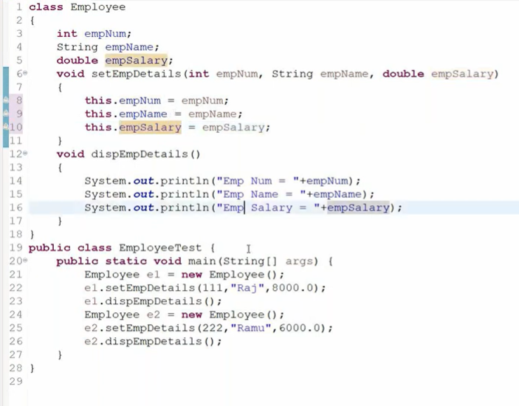

26) Points about constructor

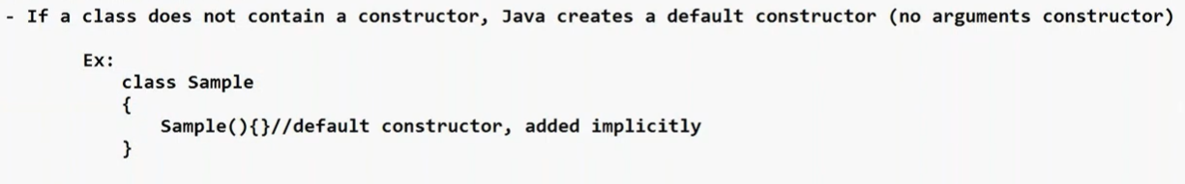

If a class contains parameterized constructor then it is the responsibility of the programmer to make a default constructor else error will come if object is initialized using the default constructor.

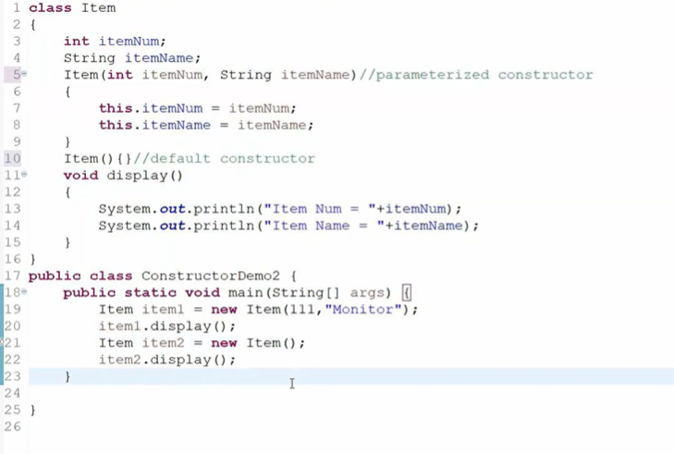

27) static k.w

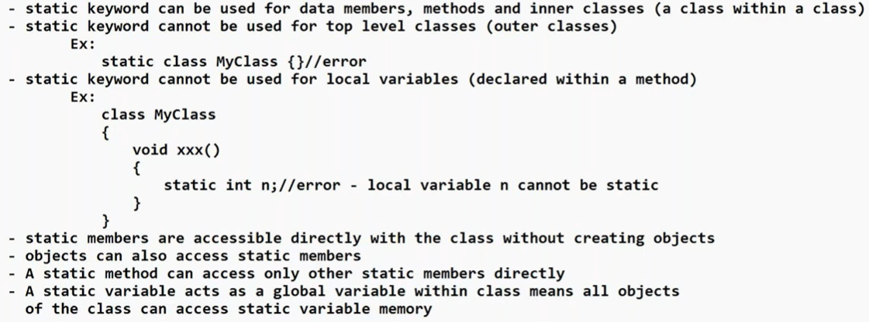

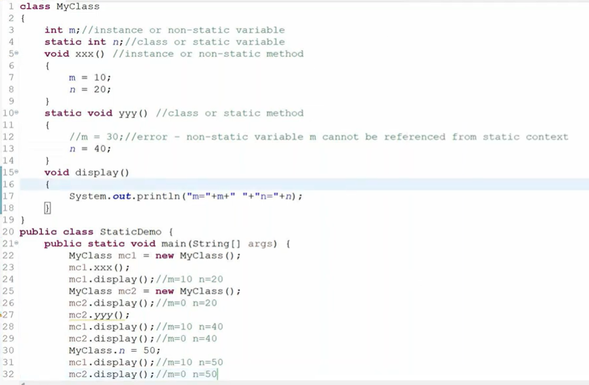

28) packages in Java

Why we need folders: to store related files/data together

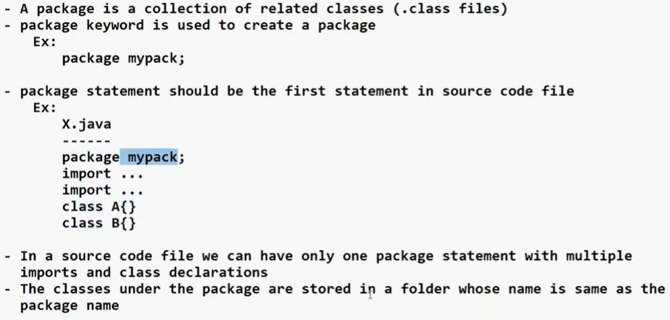

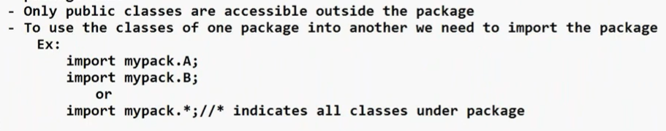

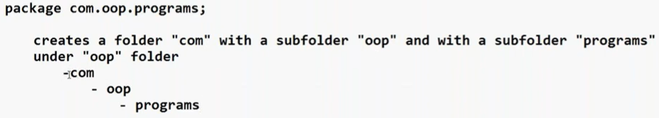



29) **Inheritance** is a mechanism in which **one class acquires the properties and behaviors of another class**.

Java does not support multiple inheritance due to ambiguities.

Class C extends A,B{} // error

Reason for ambiguity:

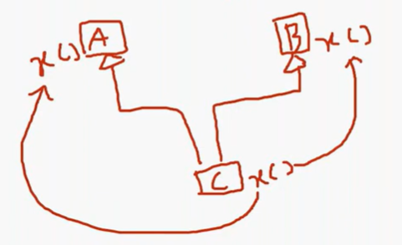

From which class x method has to be taken. This problem is resolved in C++ using the concept of virtual. If you make class A as virtual it take x method from B class and if you make B class as virtual it take x method from A class.

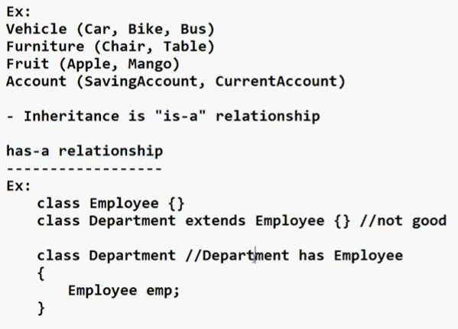

30) Polymorphism

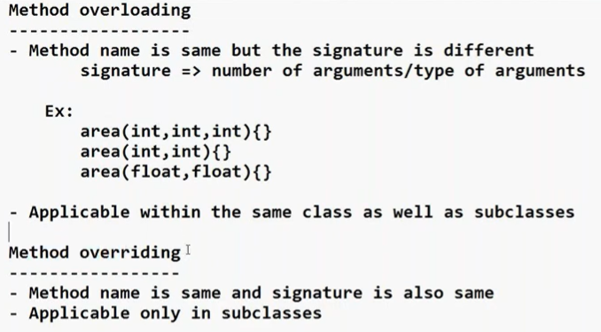

31) super reference is used to refer to the Base class members from derived class method.

32) to take input a character:

Scanner sc = new Scanner(System.in);

char c = sc.next().charAt(0);

33) Constructors in inheritance

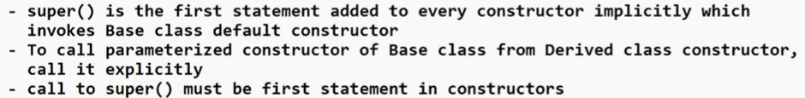

Call to super() can be anywhere in normal methods.

34) final k.w

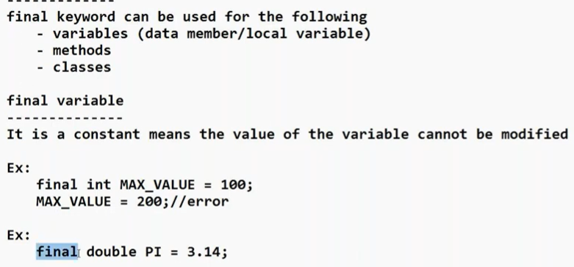

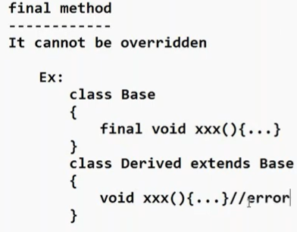

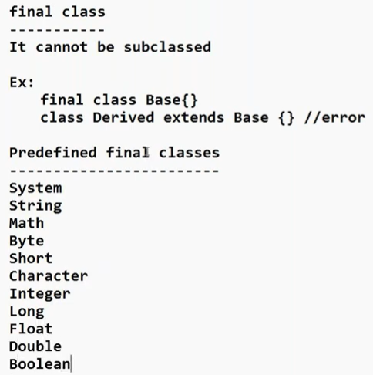

These last 8 classes has a special name called as Wrapper classes.

35) Inner classes

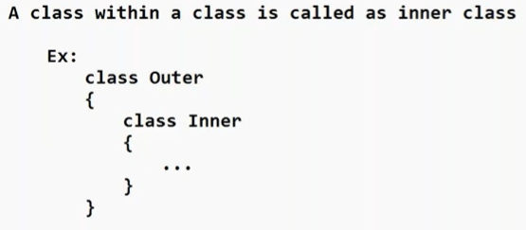

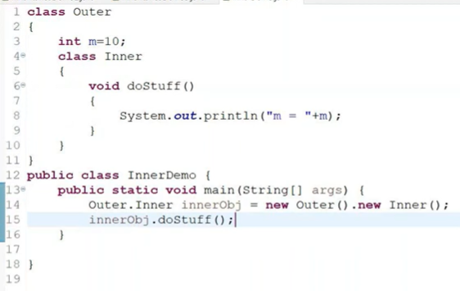

36) access modifiers

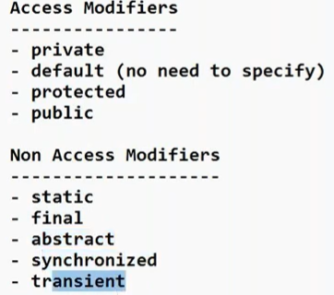

#note: out of all the modifiers, only final modifier is allowed for local variables.

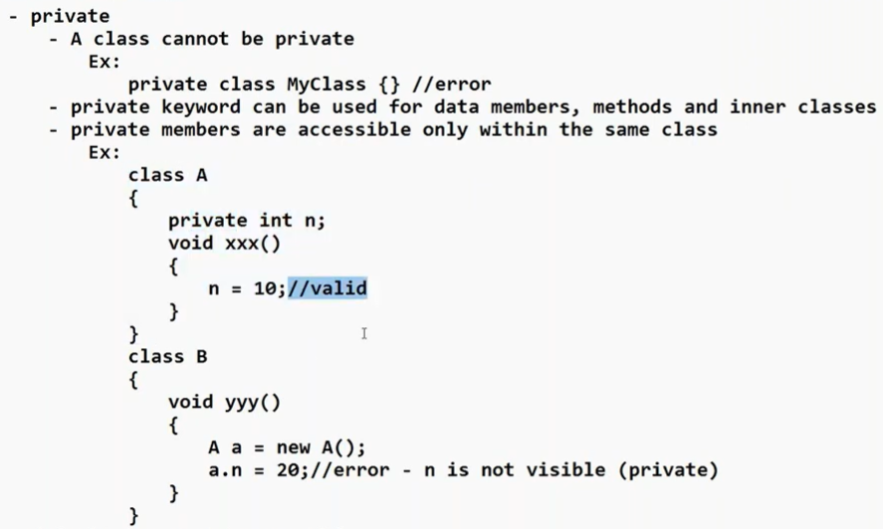

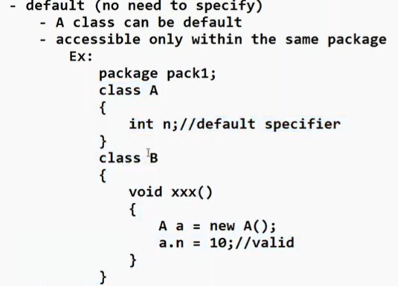

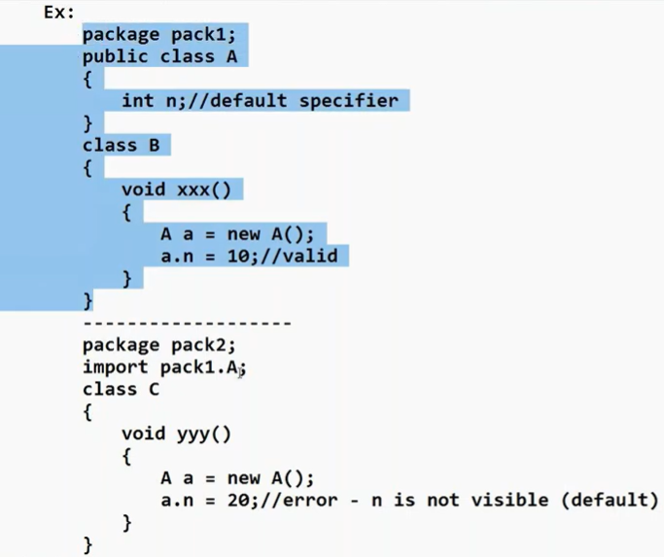

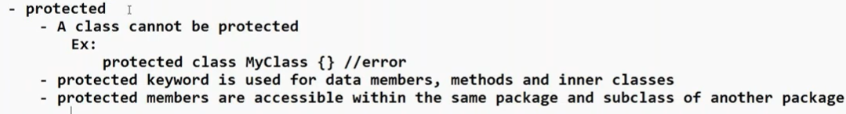

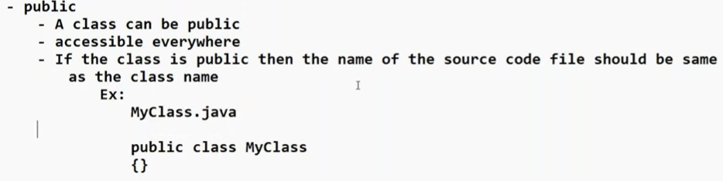

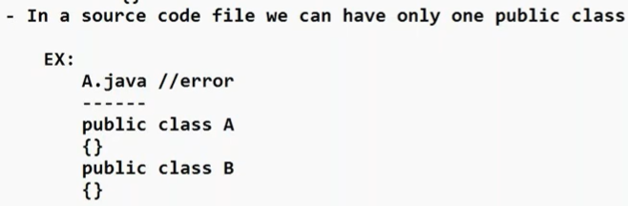

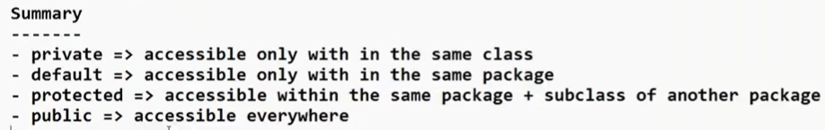

37) Encapsulation

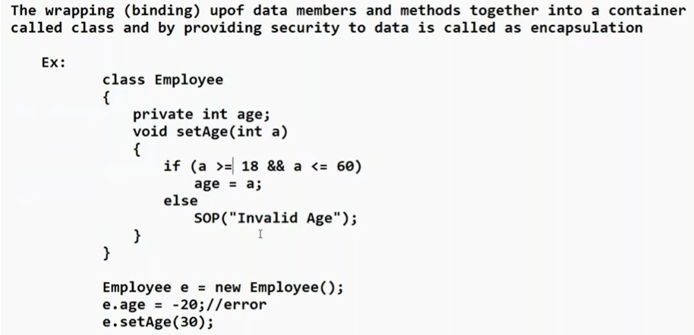

Best example of encapsulation for interview: setters and getters

38) see code below

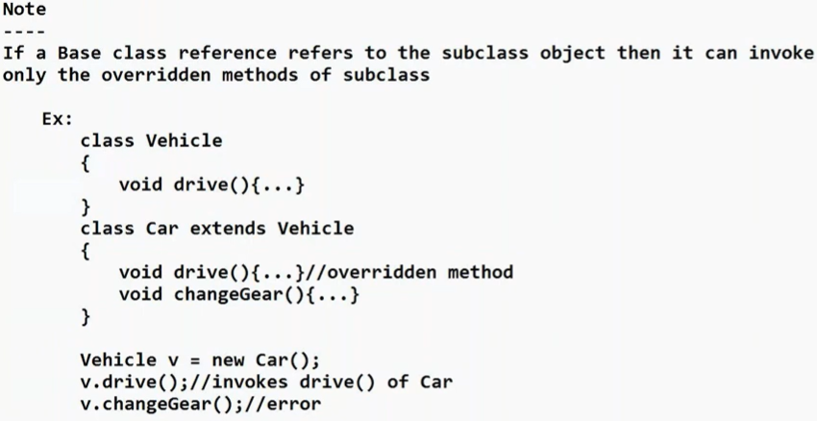

39) Abstract classes

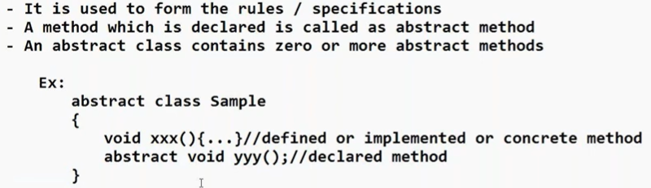



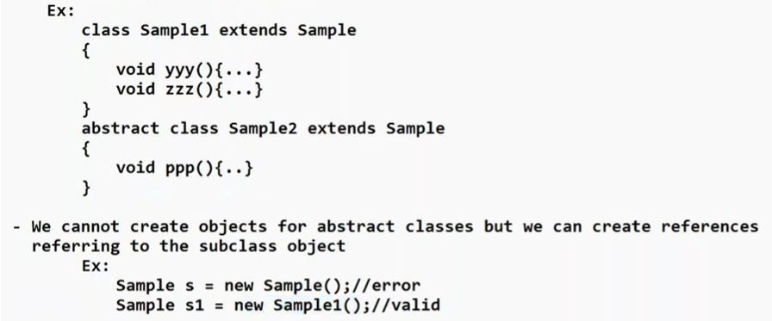

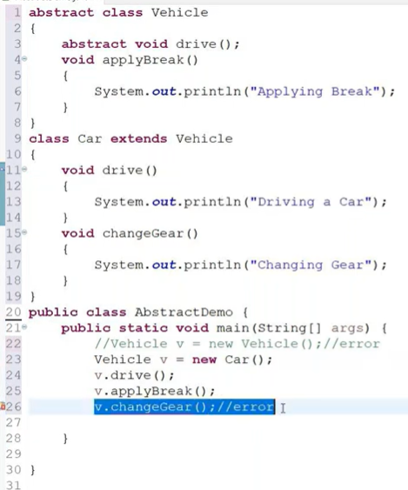

+ forces “is a” relationship

40) Interface

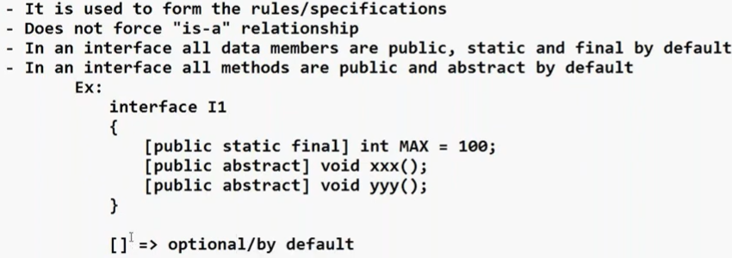

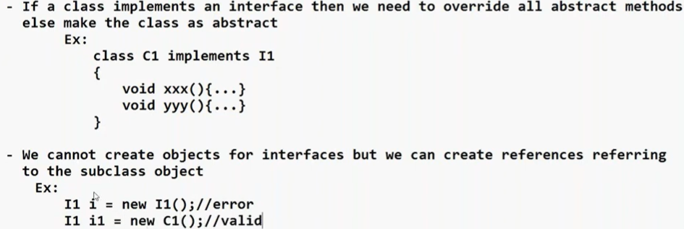

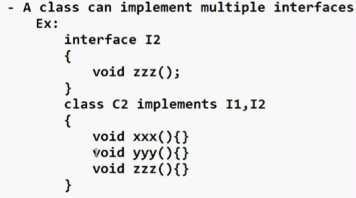

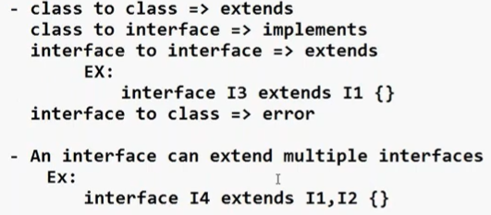





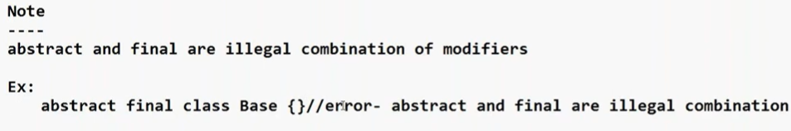

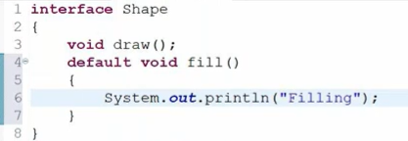

**we can have concrete (implemented) methods in an interface in Java**, but it depends on the Java version.

## **🔹 Before Java 8**

❌ **No, interfaces could NOT have concrete methods.**

An interface could only have:

* Abstract methods (no body)
* public static final variables (constants)

Example (Java 7 and before):

interface A {

void show(); // abstract method

}

## **🔹 From Java 8 onwards ✅**

Java 8 introduced:

### **1️⃣ Default Methods (Concrete Methods in Interface)**

They use the default keyword.

interface A {

void show(); // abstract

default void display() { // concrete method

System.out.println("Hello");

}

}

✔ These methods have a body.  
 ✔ They are inherited by implementing classes.  
 ✔ They can be overridden.

### **2️⃣ Static Methods in Interface (Java 8)**

interface A {

static void greet() {

System.out.println("Hi");

}

}

✔ Called using interface name:

A.greet();

## **🔹 From Java 9 onwards ✅**

Java 9 added:

### **3️⃣ Private Methods in Interface**

Used internally by default methods.

interface A {

default void show() {

helper();

}

private void helper() {

System.out.println("Private method");

}

}

✔ Cannot be accessed outside the interface  
 ✔ Used for code reuse inside interface

41) Java coding standards

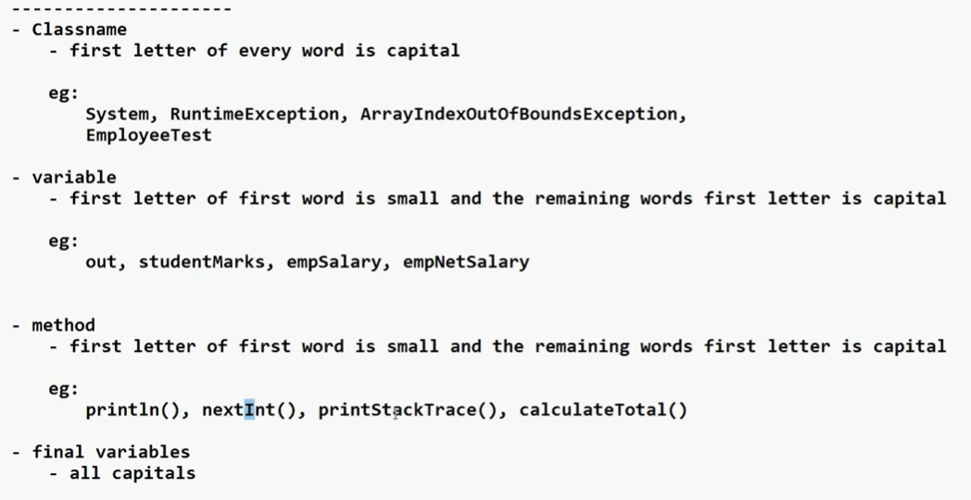

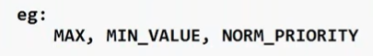

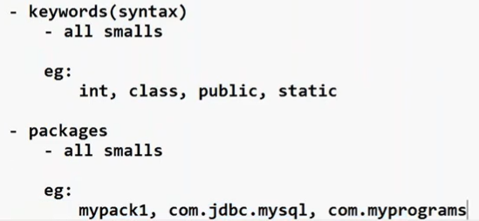

42) java.lang package

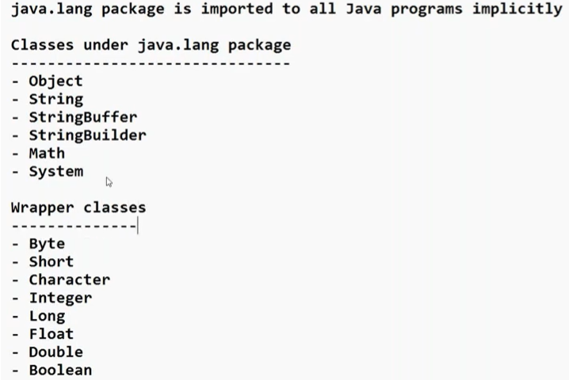

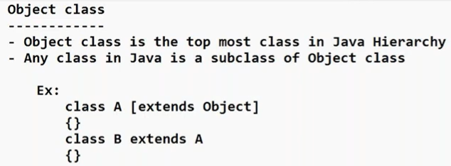

In java objects are created in a type of temporary memory called as Heap memory.

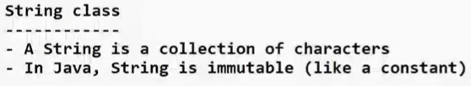

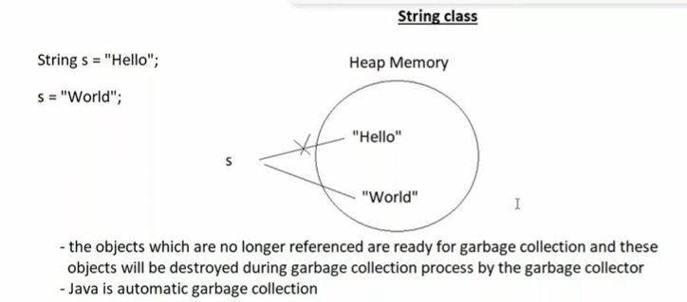

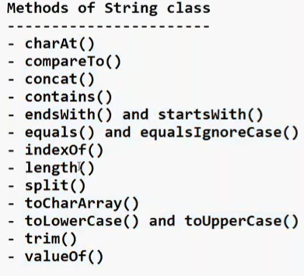

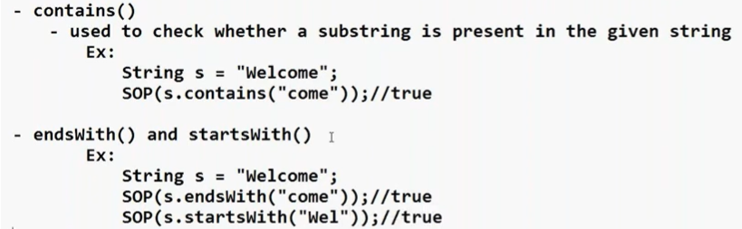

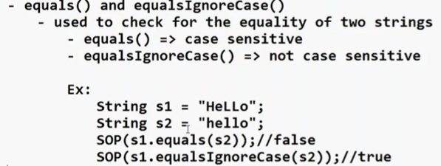

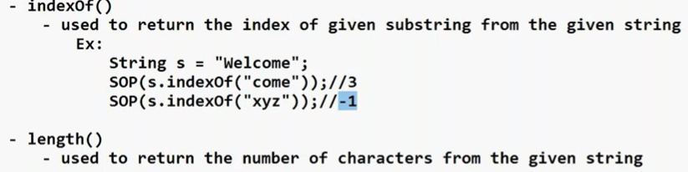

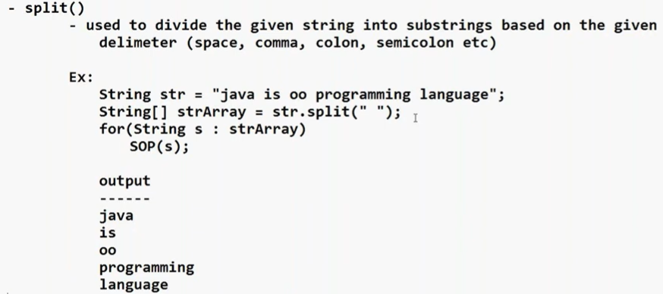

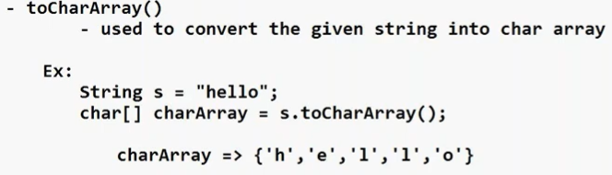

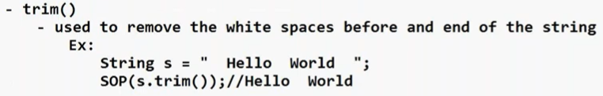

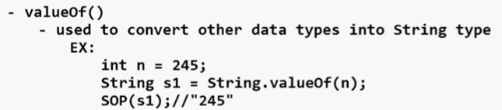

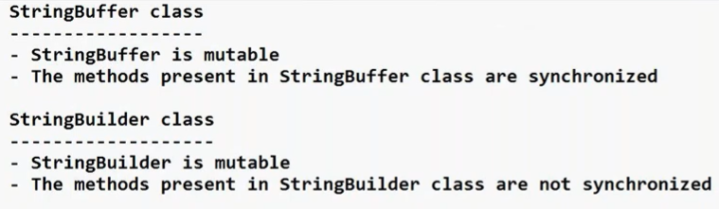

43) see below code

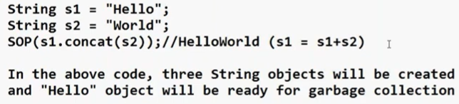

44) Generating random numbers

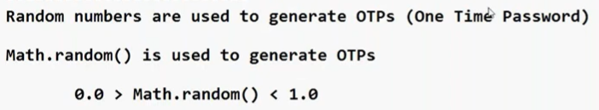

Generating 4 digit and 6 digit OTPs

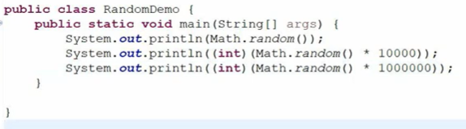

45) Wrapper classes

Two objects will be created in below code

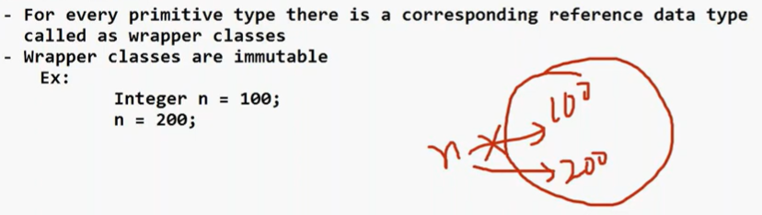





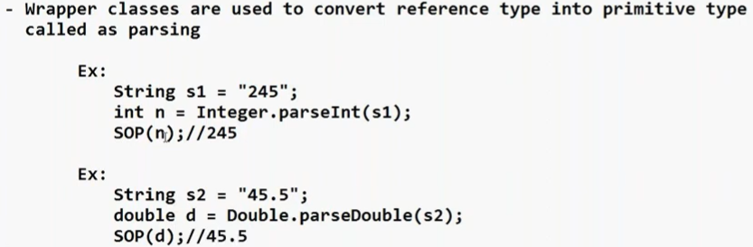

46) Exceptional Handling

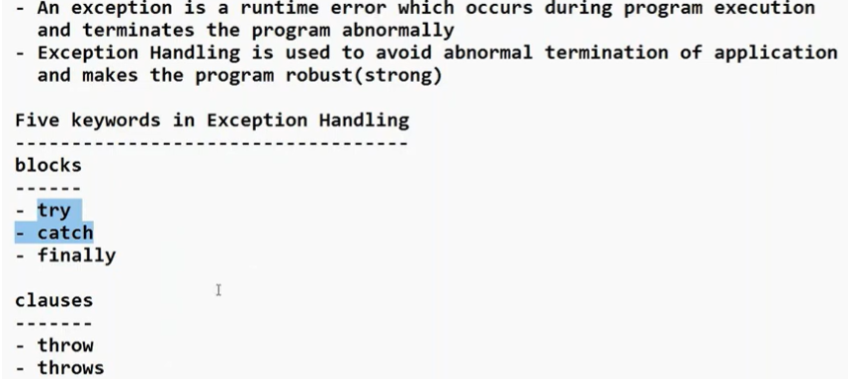

Try and catch block:

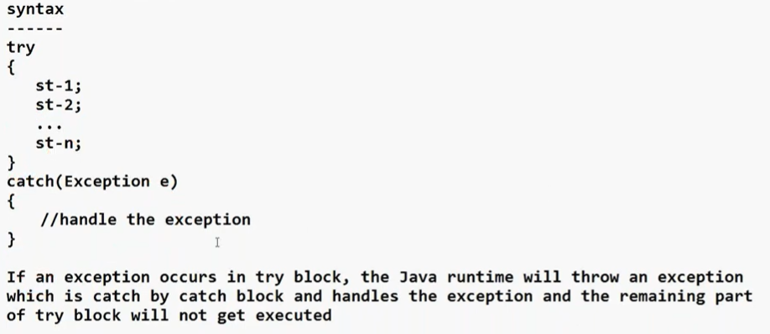

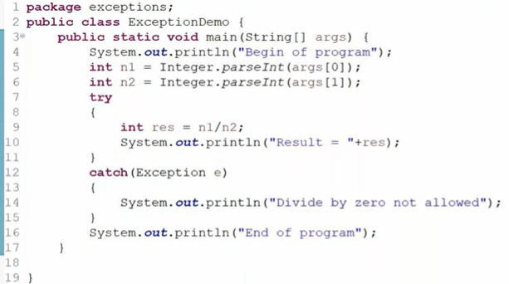

To see the error message in red color use System.err.println(“error message goes here”)

As a programmer we only consider handling the exception. Error we don’t handle like JVM goes out of memory.

Exception hierarchy: study from your .docx java files in codebase.

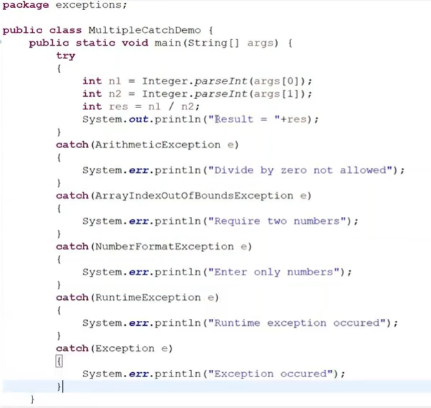

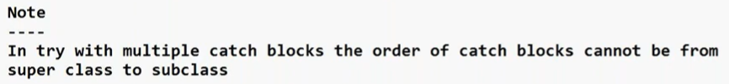

Finally block:

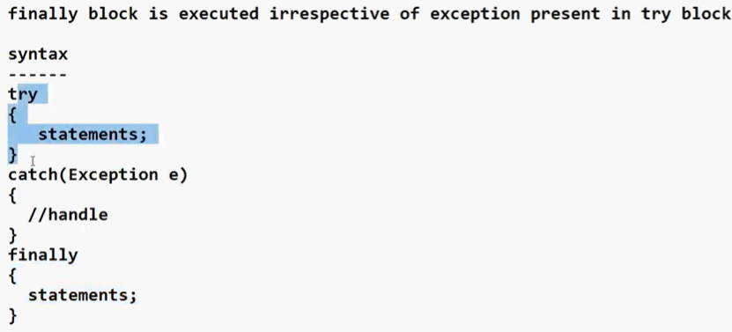

We keep closing operation in finally block so db connection always gets closed.

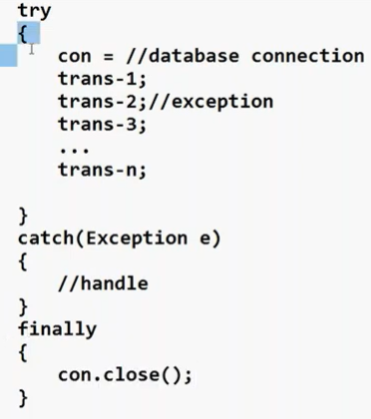

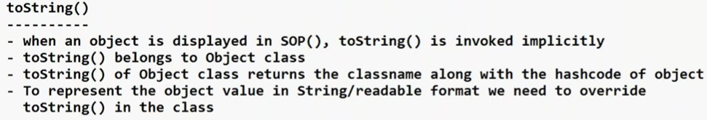

User defined exceptions:

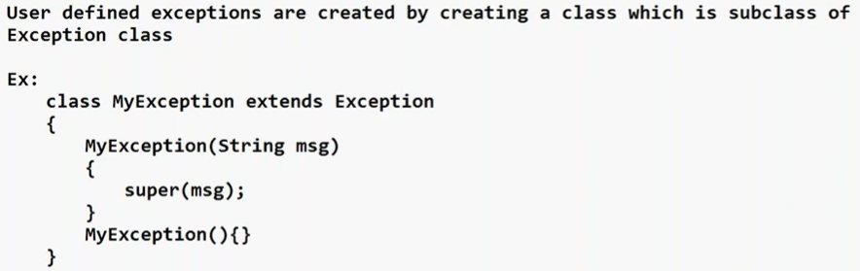

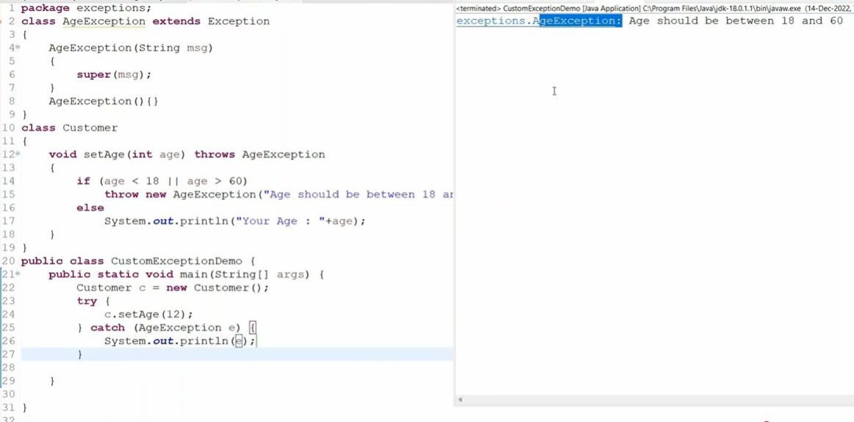

47) typecasting is between primitive to primitive and ref to ref only and not between primitive to ref and vice versa.

48) Strings[] args demo

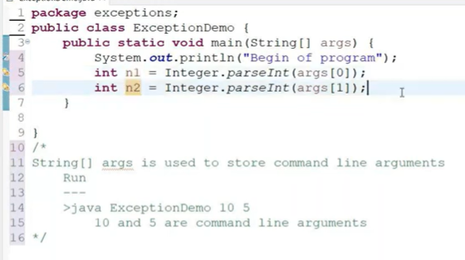

49) Multi-threading

Multi-tasking: opening multiple tabs in browser

Multi-threading: opening multiple compose within one gmail tab is multi-threading



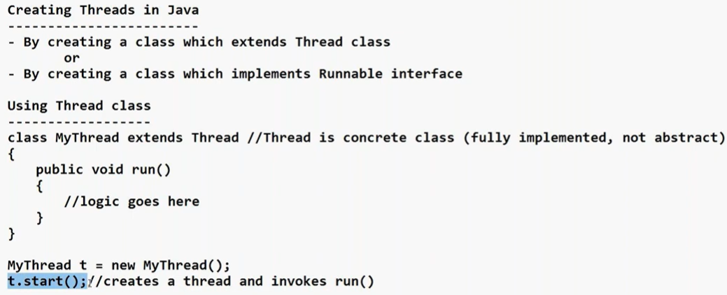

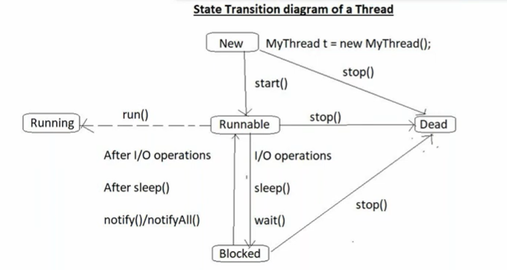

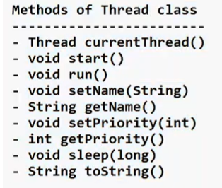

Whenever we are using a predefined class and we have not imported an explicit package for it then by default it belongs to java.lang package.

Which thread will run first is not in hands of the programmer. The CPU decides it.

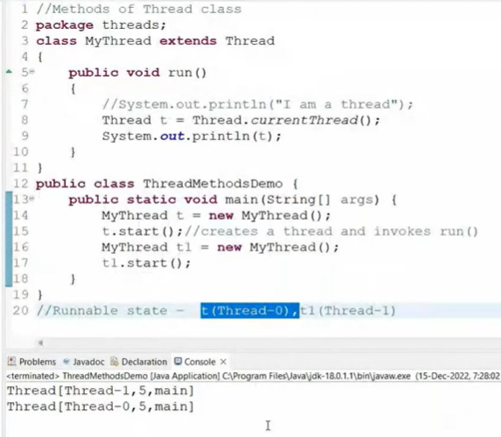

currentThread() -> returns the name, priority and the thread group

Whenever you need to create a thread use .start() only. If you will use .run() it is not a thread. It will execute and complete first then the other will work. Act like a normal flow.

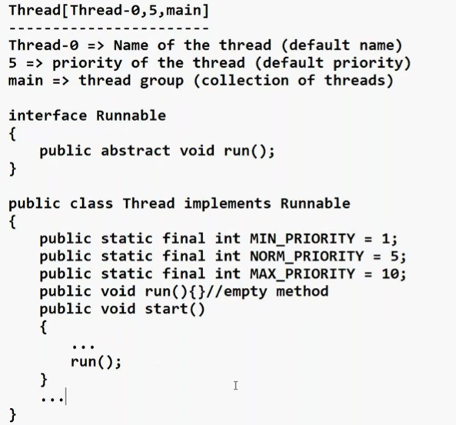



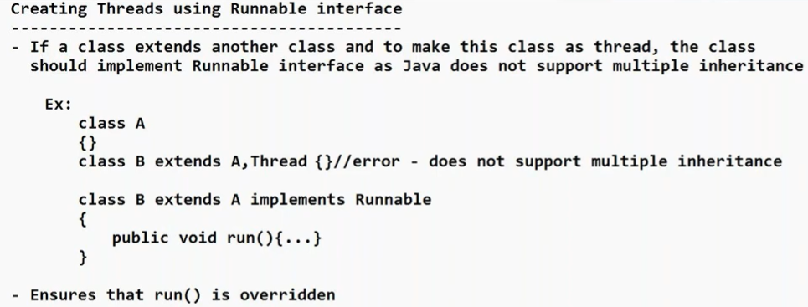

When we are using runnable interface then we have to pass the runnable object as parameter to start the thread:

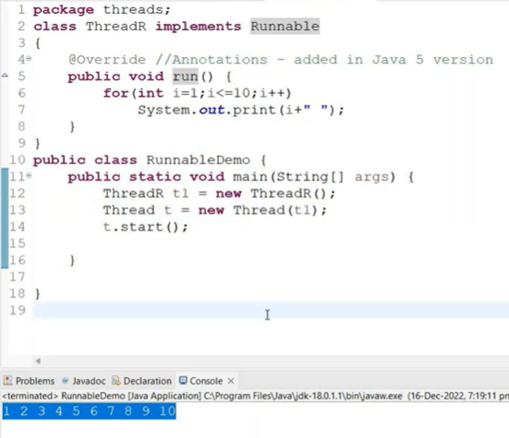

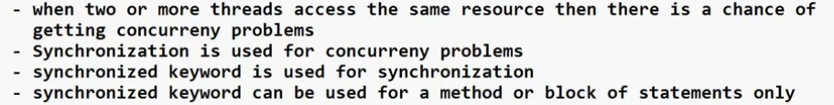

Using synchronized k.w it do not let another thread enter into the method unless one thread is completed.



But in banking application, correctness is more important than speed hence we use.

50) Collections

They are used to collect the elements of variable size.

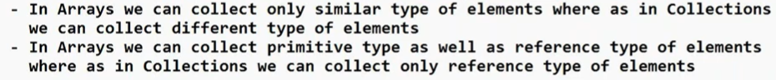

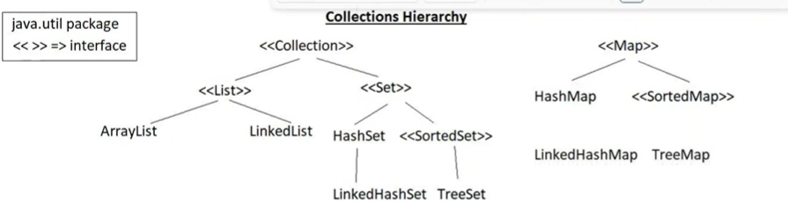

When more num of insert and delete operations then use LinkedList; without <<>> symbol are subclasses.

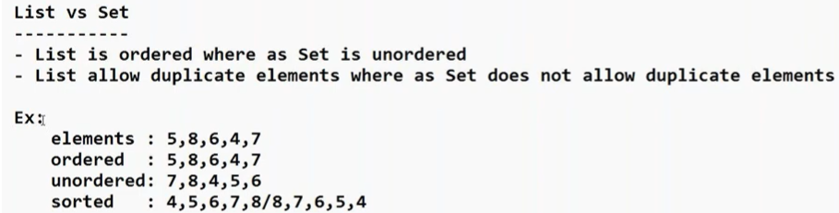

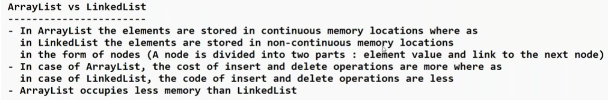

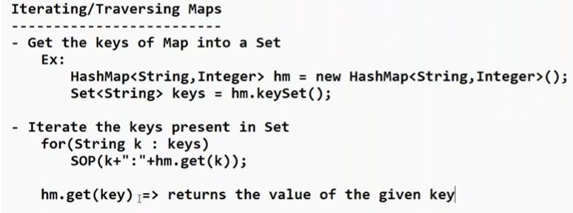

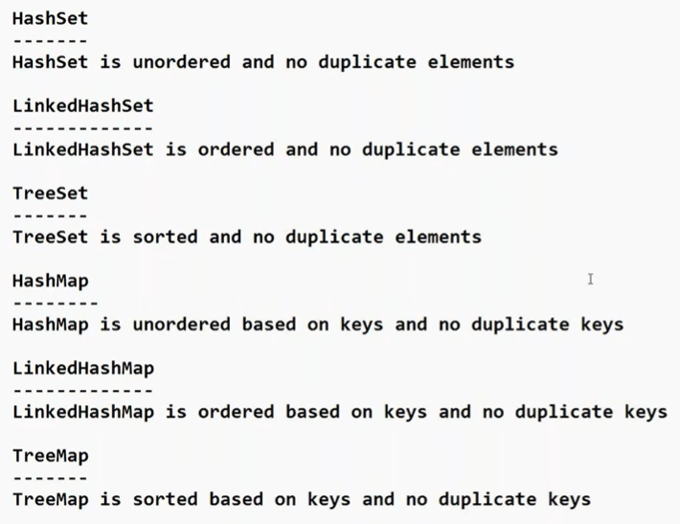

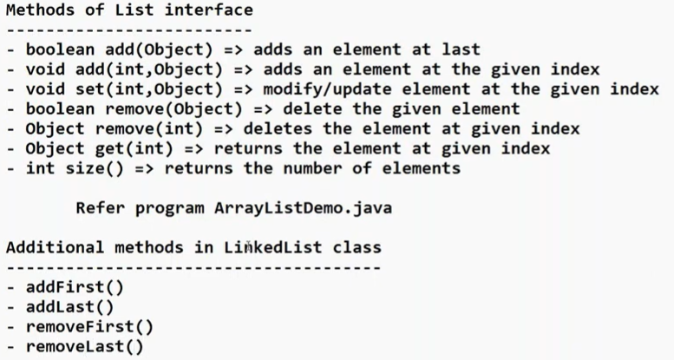

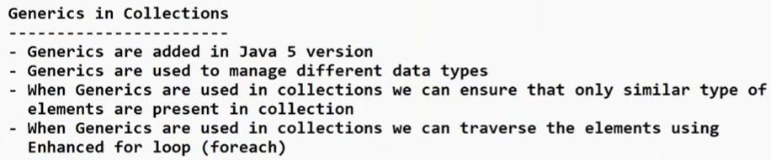



51) Autoboxing: if you pass primitive dataType to collections, it will internally convert into reference datatype.

52) Java 8 version features

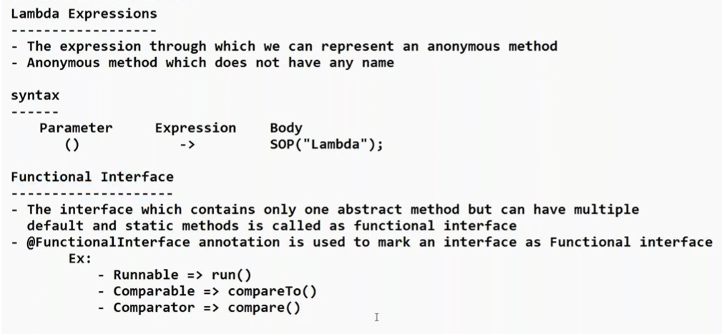

Java Stream api

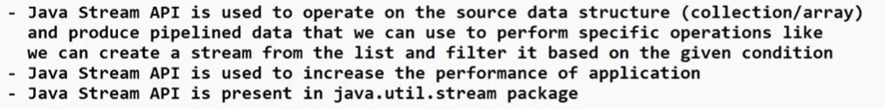

53) Database concepts

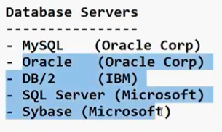

Default MySQL port = **3306**

**mysql -u root -p // in cmd and login with your password**

54) JDBC

Real jdbc vid of 106 playlist is here:

<https://youtu.be/3jP7GIz31YE?si=07S6EKO0ENLwgC73>

See below 7 steps

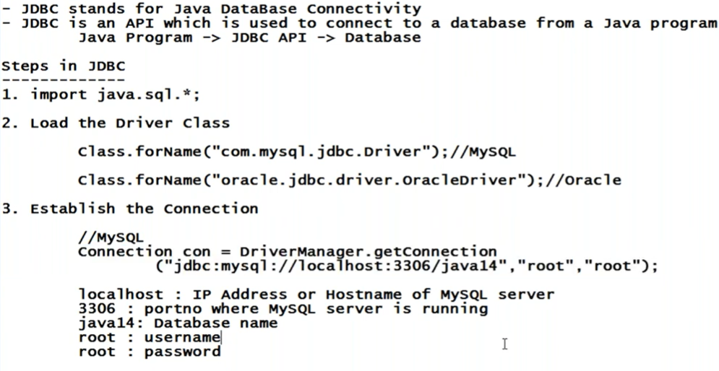

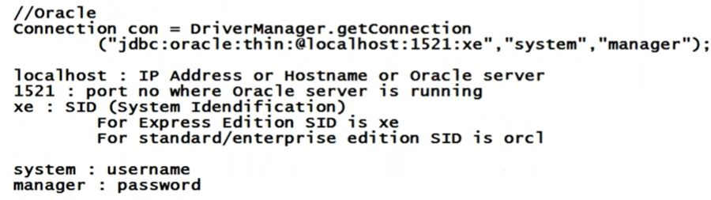

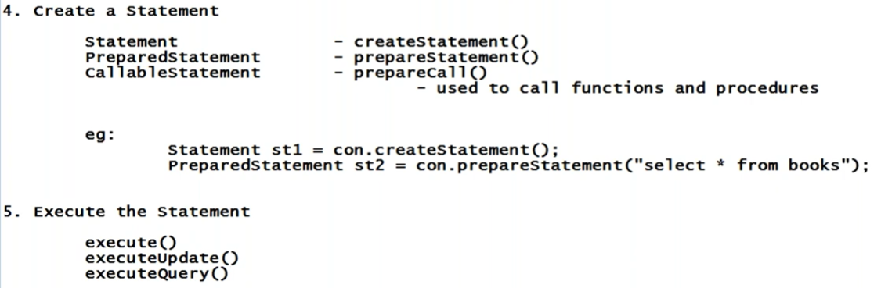

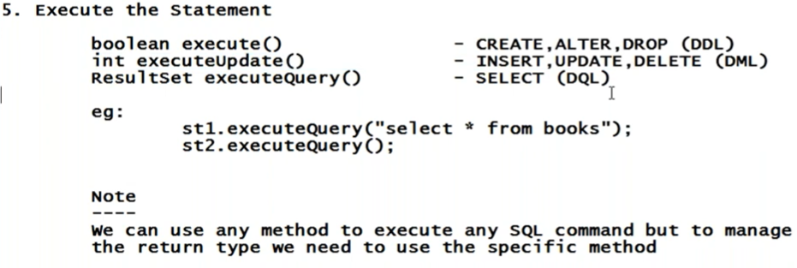

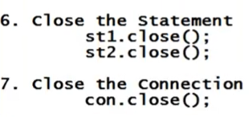

55) Problem of solving import java.sql.*; in eclipse:

When creating new project like MyProj2 uncheck the **Create module-info.java fil**e box.

If you don’t uncheck it, Eclipse will create a modular project and then manually you would have to add the sql in module-info.java as:

**module MyProj {**

**requires java.sql;**

**}**

module is a **keyword** in Java (introduced in Java 9) used to **declare a module**.

Just like:

* class is used to declare a class
* interface is used to declare an interface
* package is used to declare a package

👉 module is used to declare a module.

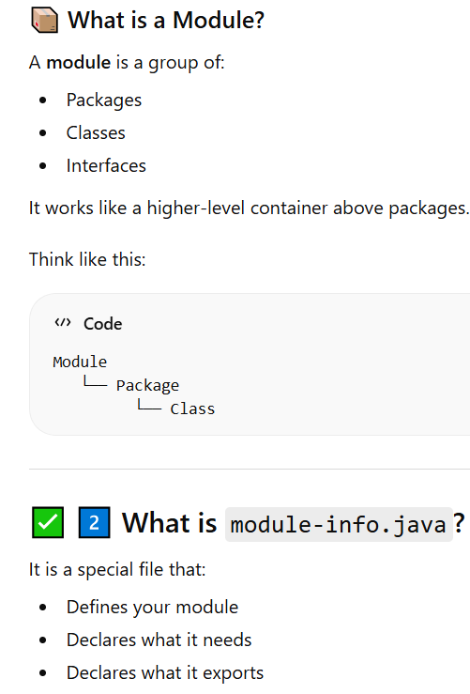

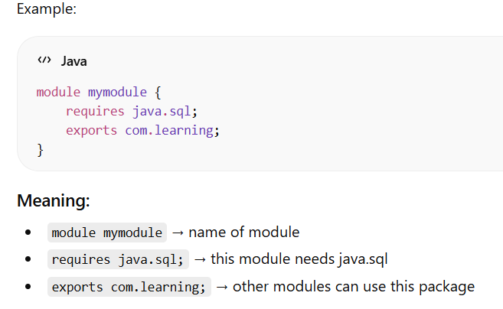

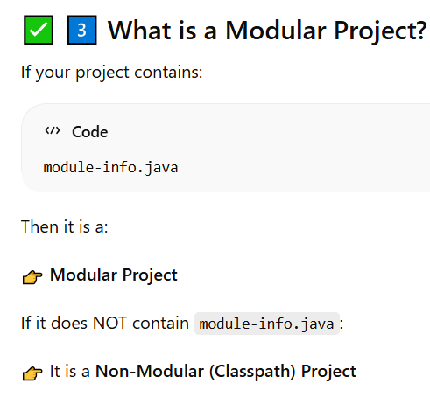

Code to connect to Mysql server:

**package** com.learning;

**import** java.sql.*;

**public** **class** JdbcMySQLDemo {

**public** **static** **void** main(String[] args) {

**try**

{

Class.*forName*("com.mysql.jdbc.Driver");

Connection con = DriverManager.*getConnection*("jdbc:mysql://localhost:3306/java_database", "root", "your_mysql_password");

System.***out***.println("Connected");

con.close();

}

**catch**(Exception e)

{

System.***err***.println(e);

}

}

}

After running above code you will get:

java.lang.ClassNotFoundException: com.mysql.jdbc.Driver

To solve this error download:



Above .jar file is old. Follow below steps:

# **✅ STEP 1: Download MySQL Connector 8**

Go to the official MySQL site:

👉<https://dev.mysql.com/downloads/connector/j/>

## **🔹 On that page:**

### **1️⃣ Select:**

Operating System: Platform Independent

Very important.

### **2️⃣ Download this file:**

Look for something like:

mysql-connector-j-8.3.0.zip

OR latest 8.x version (8.4.x is also fine)

⚠️ DO NOT download:

* source code
* .rpm
* .msi installer

You need the **ZIP file (Platform Independent)**.

### **3️⃣ Click Download**

It will ask to login.

👉 Click:

No thanks, just start my download

Download will start.

# **✅ STEP 2: Extract ZIP**

After downloading:

1. Right click the ZIP
2. Click **Extract All**
3. Open extracted folder

Inside you will see:

mysql-connector-j-8.x.x.jar

This is the file you need.

Example:

mysql-connector-j-8.3.0.jar

Now right click on MyProj2 in eclipse; go to build path then configure build path; select libraries. Select classpath and add external jar file by selecting location of .jar file that you extracted from the .zip

Run the .java file. It will say connected. Below is java code:

**package** com.learning;

**import** java.sql.*;

**public** **class** JdbcMySQLDemo {

**public** **static** **void** main(String[] args) {

**try**

{

Class.*forName*("[com.mysql.cj](http://com.mysql.cj).jdbc.Driver"); // note cj is here. It is not in above

Connection con = DriverManager.*getConnection*("jdbc:mysql://localhost:3306/java_database", "root", "your_mysql_server_password");

System.***out***.println("Connected");

con.close();

}

**catch**(Exception e)

{

System.***out***.println(e);

}

}

}

Code for creating table in mysql from java:

**package** com.learning;

**import** java.sql.*;

**public** **class** JdbcMySQLDemo {

**public** **static** **void** main(String[] args) {

**try**

{

Class.*forName*("com.mysql.cj.jdbc.Driver");

Connection con = DriverManager.*getConnection*("jdbc:mysql://localhost:3306/java_database", "root", "password");

System.***out***.println("Connected");

Statement st = con.createStatement();

st.execute("create table books (bno int(3), bname varchar(10), price float(4))");

System.***out***.println("Table created");

st.close();

con.close();

}

**catch**(Exception e)

{

System.***out***.println(e);

}

}

}

Code for inserting data from java to mysql:

st.executeUpdate("insert into books values(101, 'C', 100)");

st.executeUpdate("insert into books values(102, 'DSA', 200)");

st.executeUpdate("insert into books values(103, 'CP', 500)");

System.***out***.println("Inserted");

Update code:

**int** n = st.executeUpdate("update books set price=600");

System.***out***.println(n+ " records updated");

Delete code:

**int** n = st.executeUpdate("delete from books");

System.***out***.println(n+" records deleted");

Imp code on how to query the data from database in java code:

ResultSet rs = st.executeQuery("select * from books");

**while (rs.next())**

**{**

**System.out.print(rs.getInt("bno")+" ");**

**System.out.print(rs.getString("bname")+" ");**

**System.out.println(rs.getFloat(3));//3 is column no (price)**

**}**

Prepared statement code: used to avoid writing query multiple time.

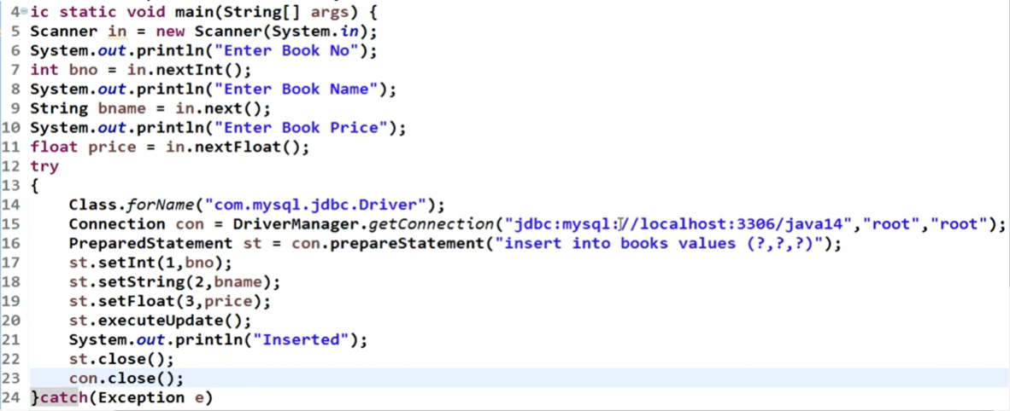

55) IO Package

Used to save data from ram to permanent memory.

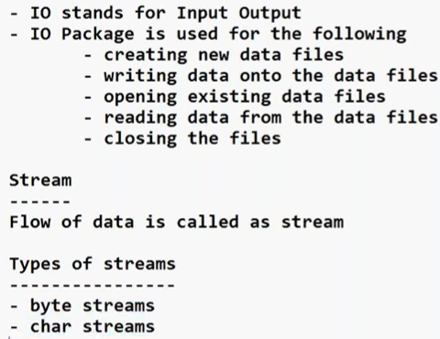

This means that in java we can make the data flow in 2 formats only, either in byte stream or in char stream.

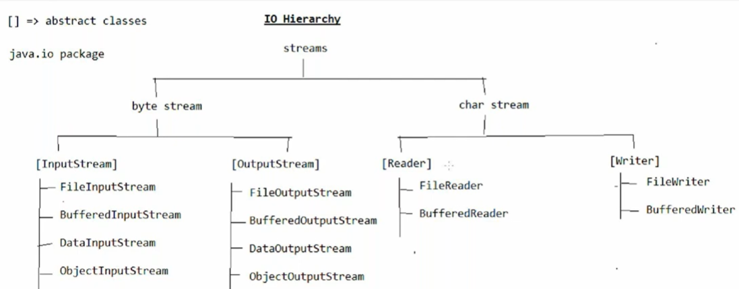

**PrintWriter belongs to the Character Stream in Java.** ✅

## **🔹 Why?**

Java has two main types of streams:

### **1️⃣ Byte Stream**

* Works with raw bytes (8-bit)
* Examples: FileInputStream, FileOutputStream

### **2️⃣ Character Stream ✅**

* Works with characters (16-bit Unicode)
* Examples: FileReader, FileWriter, **PrintWriter**

👉 Since PrintWriter writes **characters (text data)**, it is a **Character Output Stream**.

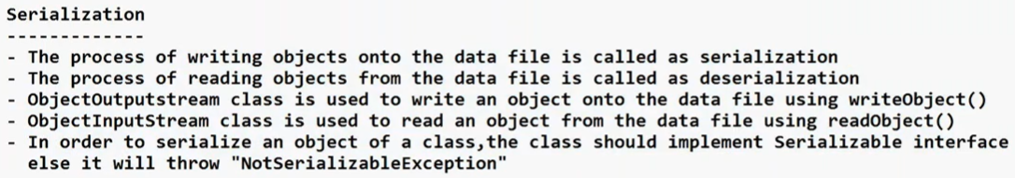



**Web Technologies(Frontend)**

**_________________________**

56) XML

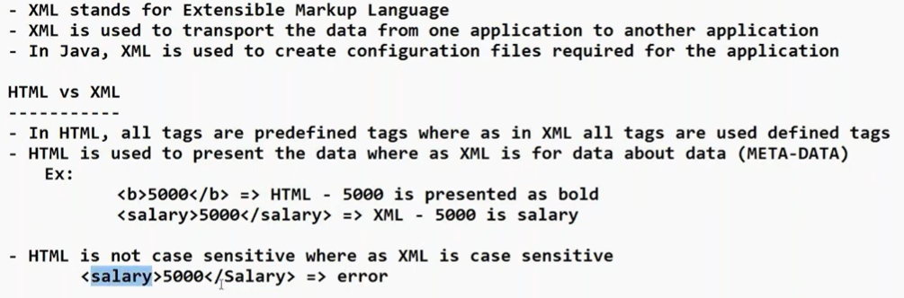

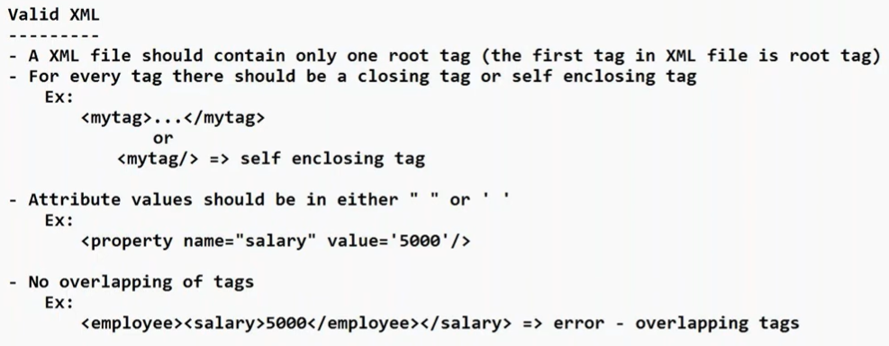

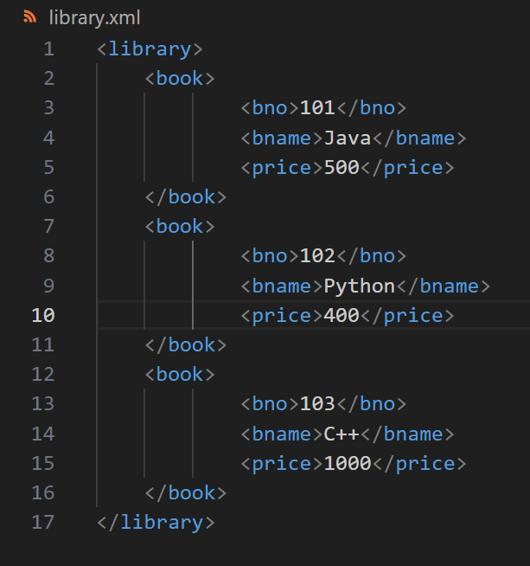

Open in browser. You will see. Library is root tag

57) JSON

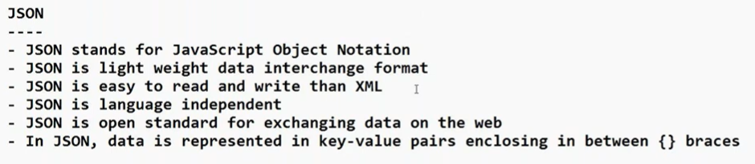

**Advanced Java / Java EE**

**______________________**

58) see below

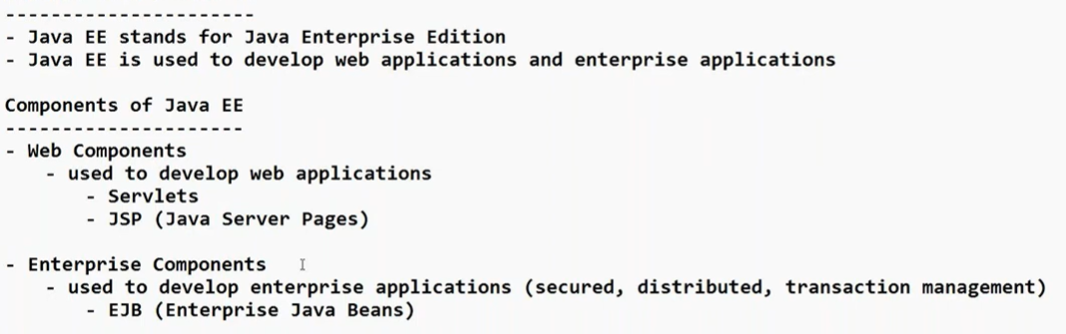

Java Beans is now outdated and we use spring framework to develop enterprise applications.

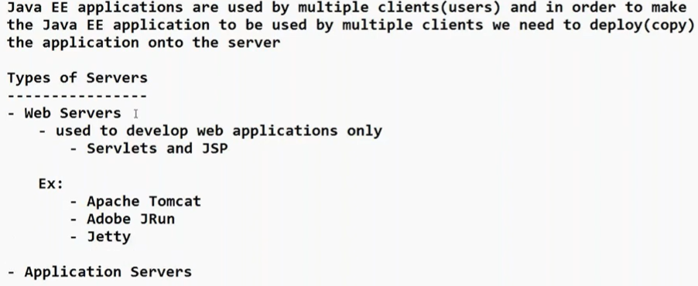

Web servers can understand Servlets and JSP only.

Web servers are subset of Application server. Application server can understand JSP, Servlets, Java beans

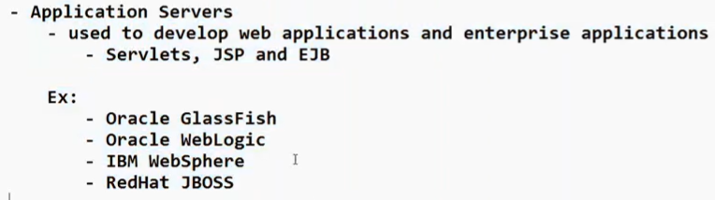

We will study Tomcat server. Once that we can do rest on our own.

59) Servlets

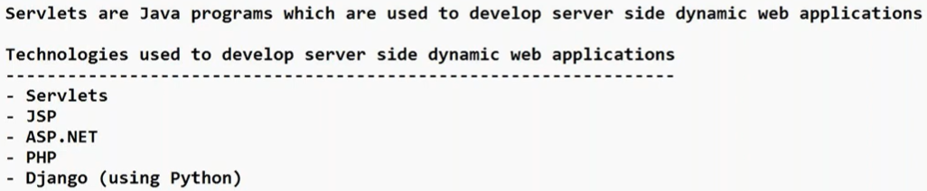

60) Servlets Hierarchy

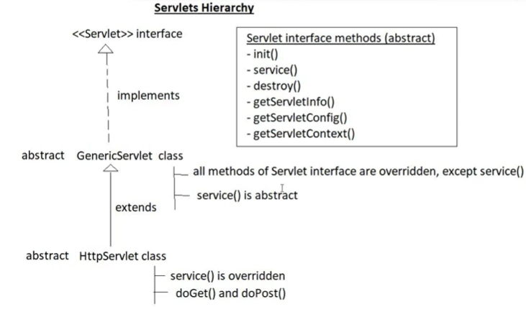

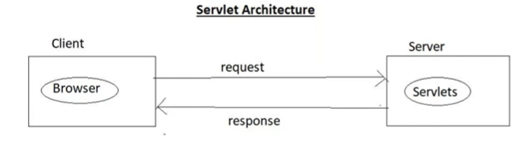

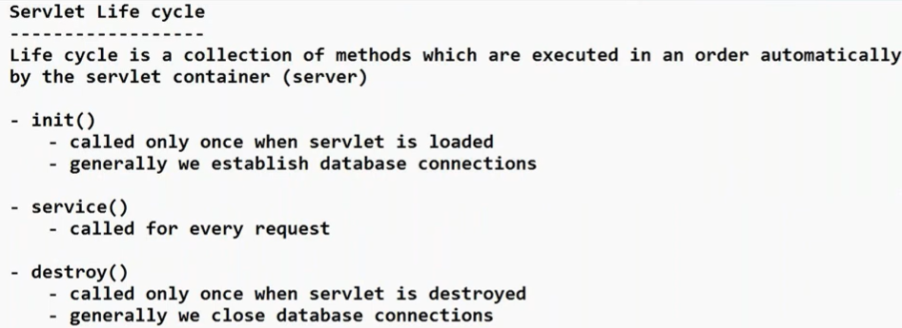

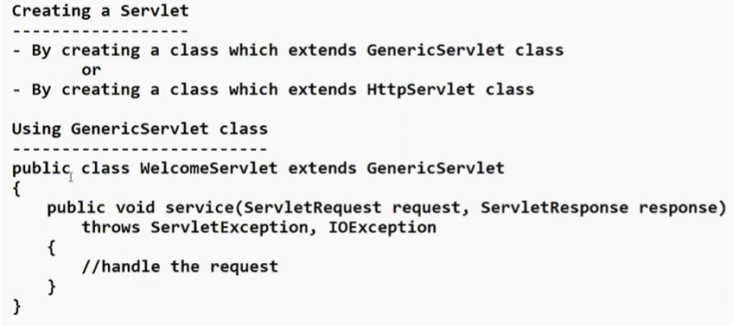

Class we keep as public because the request is coming from outside browser.

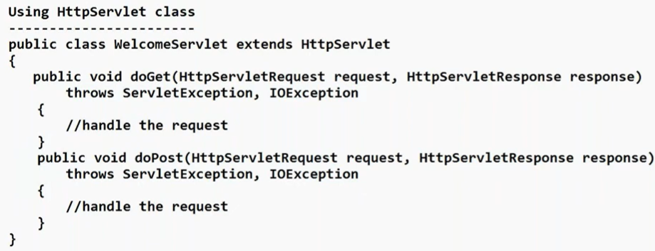

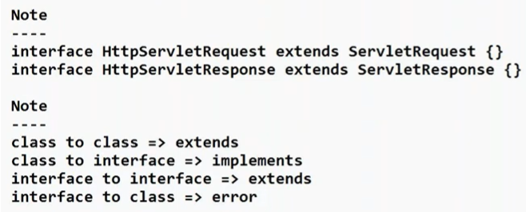

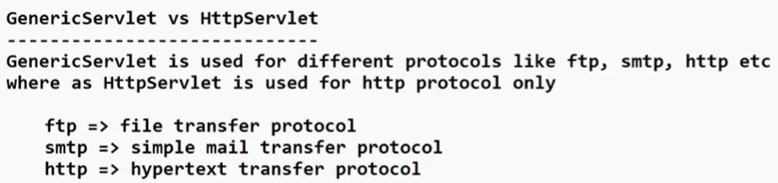

61) deployment means copy

62) Tomcat server installation and simple hello world in servlets: follow below steps

+ Download procedure of Tomcat server

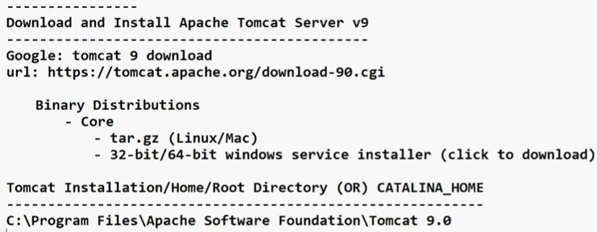

+ steps on how to develop a servlet

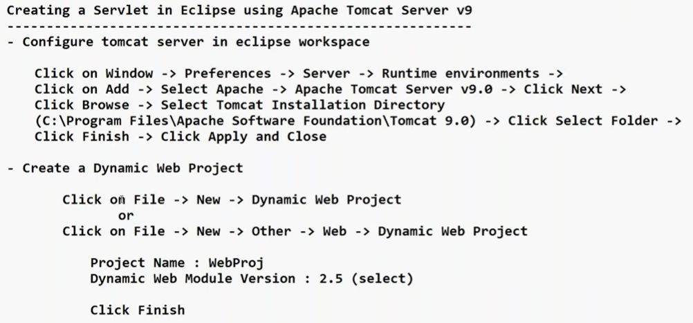

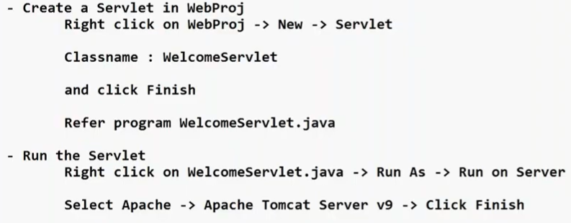

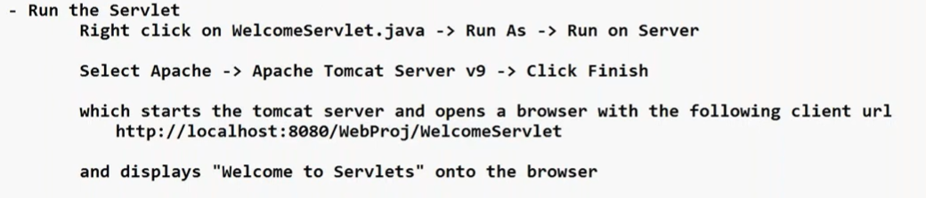

Code:

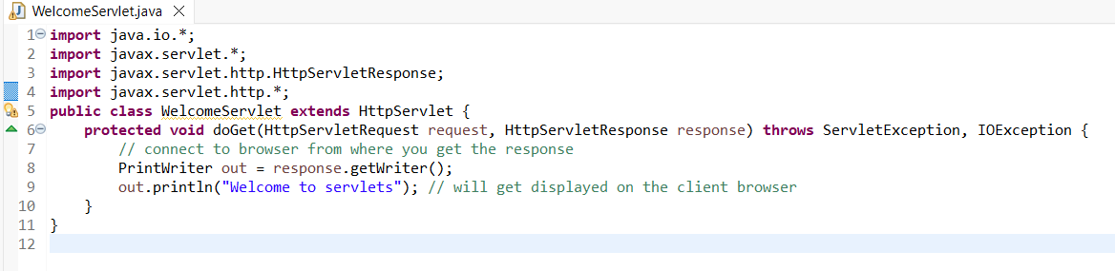

In our response we want to include some HTML tags. How we can do that as below:

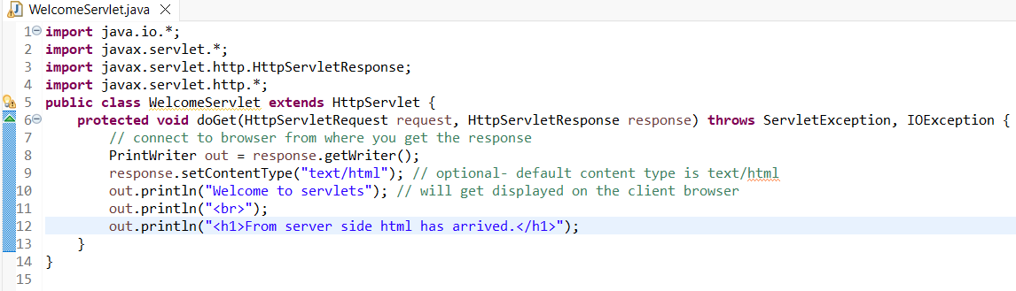

63) url theory

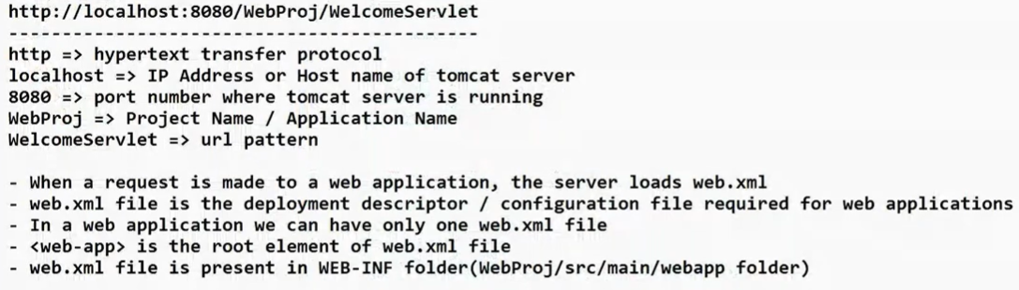

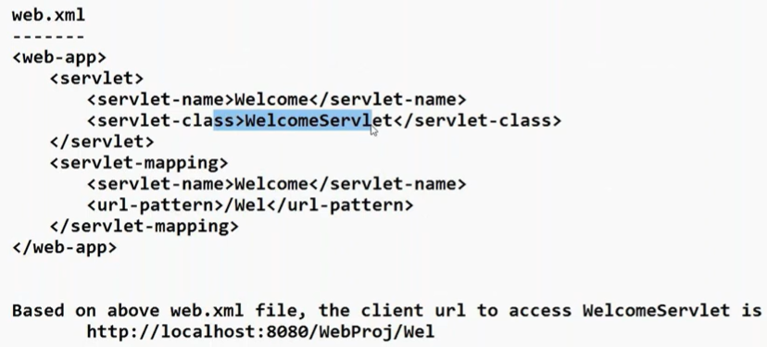

Working pipeline: Wel is url pattern, it sees Servlet name as Welcome goes to <servlet> then goes to servlet name Welcome which calls the servlet class: WelcomeServlet

64) Read frontend data into a servlet and return the response

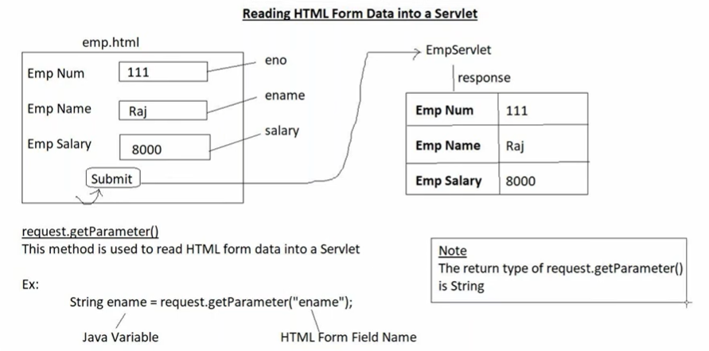

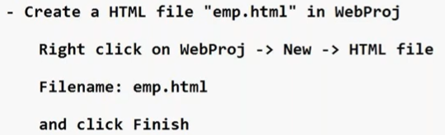

Emp.html is below:

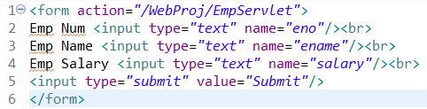

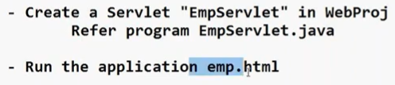

EmpServlet.java

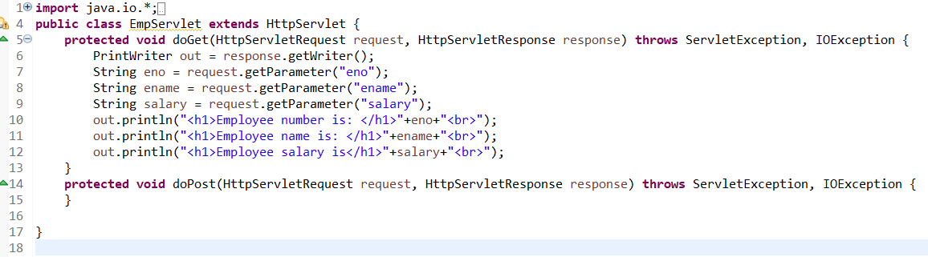

Now run code from emp.html

[localhost:8080/WebProj/EmpServlet?eno=101&ename=Aman+Raj&salary=1800000](http://localhost:8080/WebProj/EmpServlet?eno=101&ename=Aman+Raj&salary=1800000)

As you can see, data is visible in the url.

Reason:

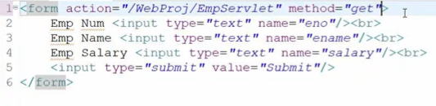

The default method is get even if you do not write it. So whenever method is get, data goes along with url.

When you do method=post then data goes as a separate page and not in the urls.

From that page it internally goes to doPost method and from there we are calling doGet method as:

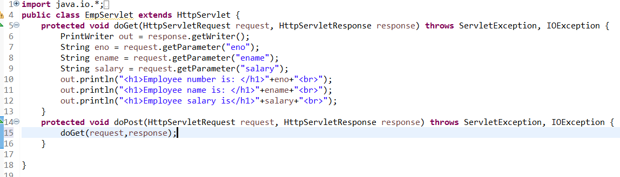

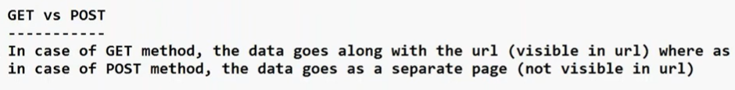

Hence when form contains password make use of post method. If no password then get is fine as it is fast.



Note that it is url pattern name and not servlet name.

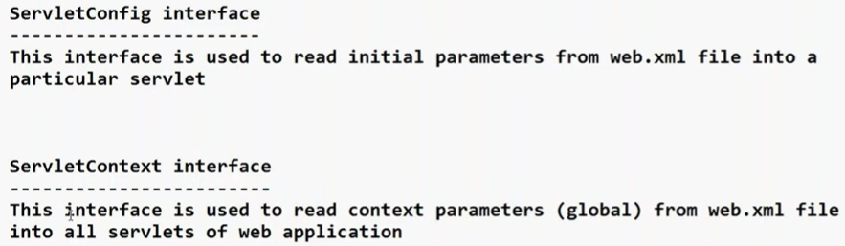

Use of above: like credentials of db connection we can pass from .xml file. Useful for programmer. (ref for practical: <https://www.youtube.com/watch?v=xd-23WdxriU&list=PLU2wpJsXyAjnmTQPc4KM7kP1dq2lnkQ5O&index=32&pp=iAQB>)

65) Developing Login application using servlets

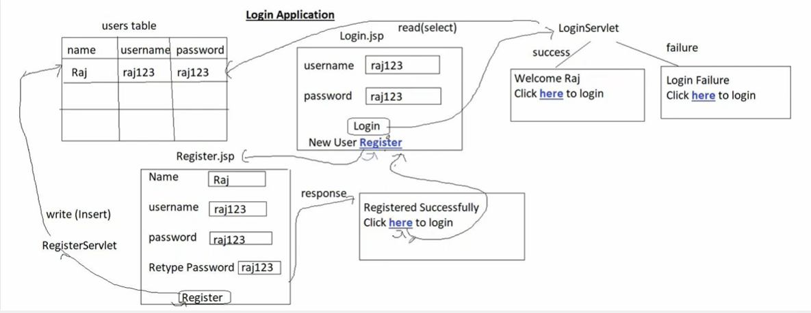

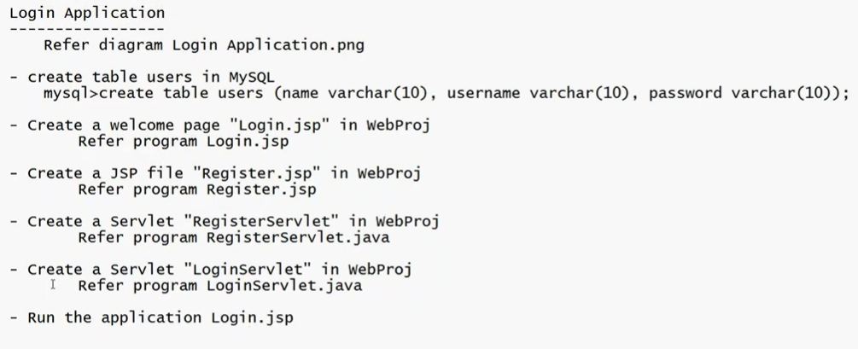

Login.jsp code below (why jsp and not html: return k.w will not work in html)

Note: run .jsp and not servlet

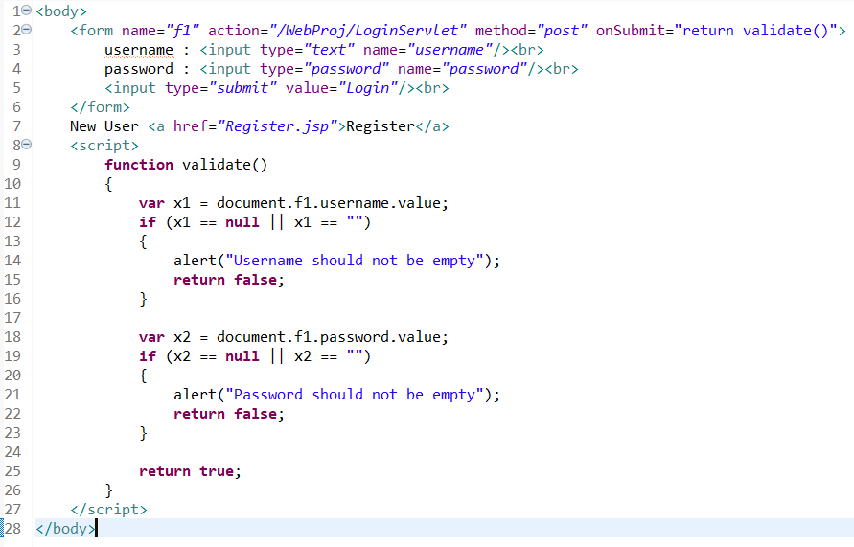

Register.jsp code

<form name=*"f2"* action=*"/WebProj/RegisterServlet"* method=*"post"* onsubmit="return validate1()">

Name : <input type=*"text"* name=*"name"*/><br>

Username : <input type=*"text"* name=*"username"*/><br>

Password : <input type=*"password"* name=*"password"*/><br>

Retype Password : <input type=*"password"* name=*"repassword"*/><br>

<input type=*"submit"* value=*"Register"*/><br>

</form>

<script>

**function** validate1()

{

**var** x1 = document.f2.name.value;

**var** x2 = document.f2.username.value;

**var** x3 = document.f2.password.value;

**var** x4 = document.f2.repassword.value;

**if** (x1 == **null** || x1 == "")

{

alert("Name should not be empty");

**return** **false**;

}

**if** (x2 == **null** || x2 == "")

{

alert("Username should not be empty");

**return** **false**;

}

**if** (x3 == **null** || x3 == "")

{

alert("Password should not be empty");

**return** **false**;

}

**if** (x3 != x4)

{

alert("Password and Retype Password should match");

**return** **false**;

}

**return** **true**;

}

</script>

</body>

Code for RegisterServlet.java

**import java.io.*;**

**import java.sql.*;**

**import javax.servlet.*;**

**import javax.servlet.http.*;**

**public class RegisterServlet extends HttpServlet {**

**Connection con;**

**public void init(ServletConfig config)**

**{**

**try**

**{**

**Class.*forName*("com.mysql.cj.jdbc.Driver");**

**con = DriverManager.*getConnection*("jdbc:mysql://localhost:3306/java_database","root","root");**

**}**

**catch(Exception e)**

**{**

**System.*out*.println(e);**

**}**

**}**

**protected void doGet(HttpServletRequest request, HttpServletResponse response) throws ServletException, IOException {**

**response.setContentType("text/html");**

**PrintWriter out = response.getWriter();**

**String name = request.getParameter("name");**

**String username = request.getParameter("username");**

**String password = request.getParameter("password");**

**try**

**{**

**PreparedStatement st = con.prepareStatement("insert into users values ('"+name+"','"+username+"','"+password+"')");**

**st.executeUpdate();**

**out.println("Registered Successfully<br>");**

**out.println("Click <a href=\"/WebProj/Login.jsp\">here</a> to login");**

**}**

**catch(Exception e)**

**{**

**out.println(e);**

**}**

**}**

**protected void doPost(HttpServletRequest request, HttpServletResponse response) throws ServletException, IOException {**

**doGet(request, response);**

**}**

**public void destroy()**

**{**

**try {**

**con.close();**

**}**

**catch (Exception e) {**

**}**

**}**

**}**

LoginServlet.java:

**import** java.io.*;

**import** javax.servlet.*;

**import** javax.servlet.http.*;

**import** java.sql.*;

**public** **class** LoginServlet **extends** HttpServlet {

Connection con;

**public** **void** init(ServletConfig config) {

**try** {

Class.*forName*("com.mysql.cj.jdbc.Driver");

con = DriverManager.*getConnection*("jdbc:mysql://localhost:3306/java_database", "root", "root");

} **catch** (Exception e) {

System.***out***.println(e);

}

}

**protected** **void** doGet(HttpServletRequest request, HttpServletResponse response)

**throws** ServletException, IOException {

response.setContentType("text/html");

PrintWriter out = response.getWriter();

String username = request.getParameter("username");

String password = request.getParameter("password");

**try** {

PreparedStatement st = con.prepareStatement(

"select * from users where username='" + username + "' and password='" + password + "'");

ResultSet rs = st.executeQuery();

**if** (rs.next()) {

String name = rs.getString("name");

out.println("Welcome " + name);

out.println("<br>Click <a href=\"/WebProj/Login.jsp\">here</a> to login");

} **else** {

out.println("Login Failure");

out.println("<br>Click <a href=\"/WebProj/Login.jsp\">here</a> to login");

}

} **catch** (Exception e) {

out.println(e);

}

}

**protected** **void** doPost(HttpServletRequest request, HttpServletResponse response)

**throws** ServletException, IOException {

doGet(request, response);

}

**public** **void** destroy() {

**try** {

con.close();

} **catch** (Exception e) {

}

}

}

For servlet copy jar folder else classnotfound error will come. Earlier since we were doing using build path but now since on tomcat server so copy:

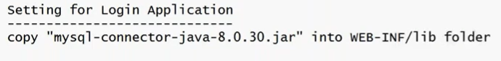

66) JSP

Using JSP, with less code we can do same task. For eg: showing current date and time in browser screen. Below in in .jsp file



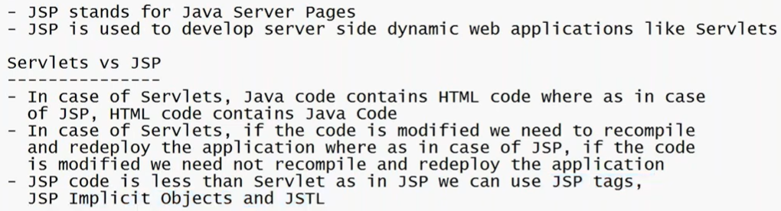

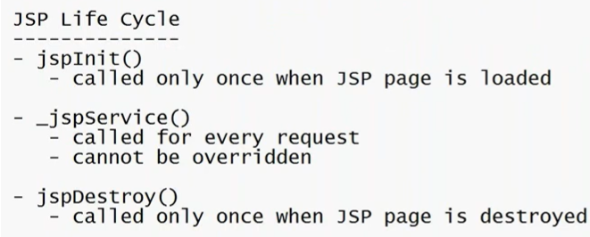

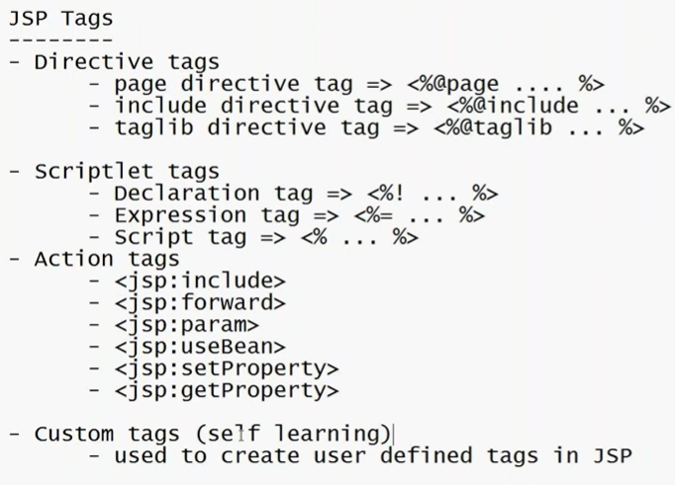

67) The code for jdbc will change based on db. Hence we use ORM frameworks like hibernate whose code is same w.r.t any database.

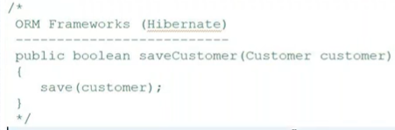

This save is same for any db.

68) Why maven?

So we do not have to manually add too many .jar files. 😃

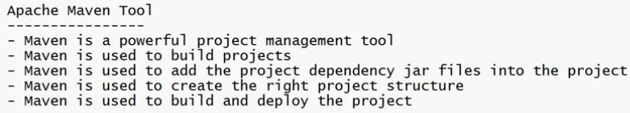

Creating a Maven project in eclipse:

com.maven (means where you want to store your .java files)

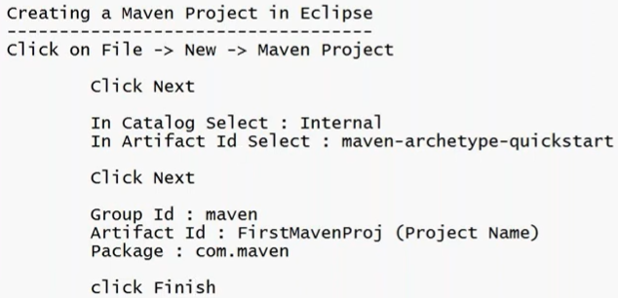

Maven literally means pom.xml files. Here we add the dependencies and do not manually add the .jar files. Also version update is very easy.

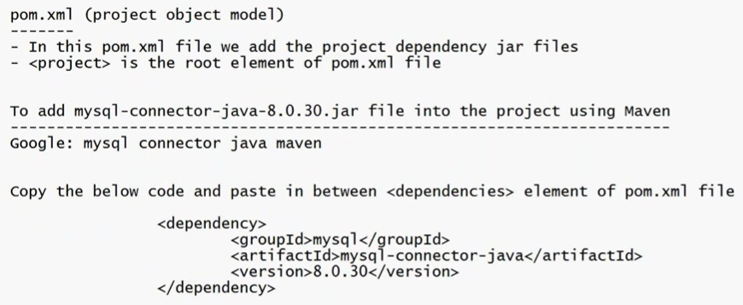

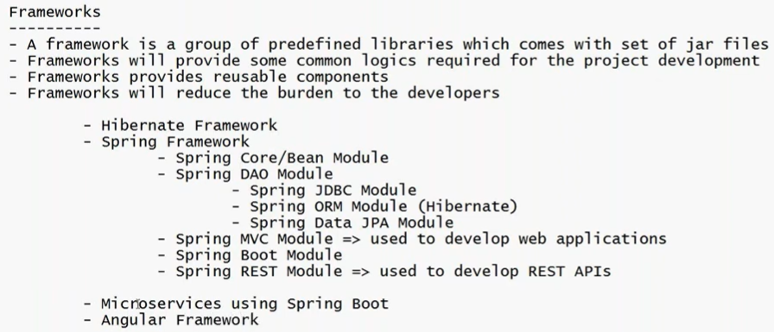

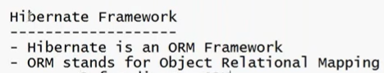

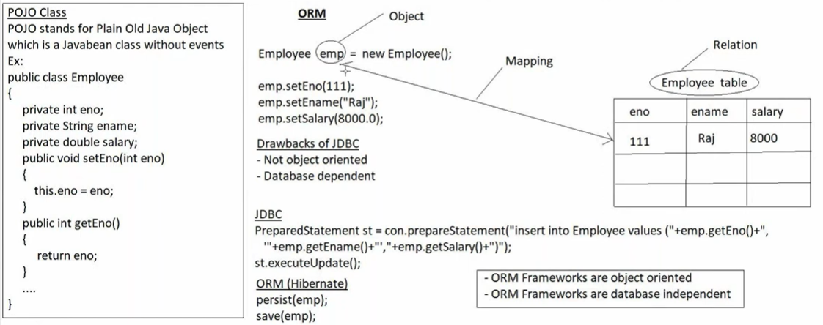

In POJO the name must start with set and get and after than same name as private data members else it will not be java bean class.

Internally, hibernate uses the jdbc concepts only.

In POJO class only private properties, constructors and setters and getters and toString method only.

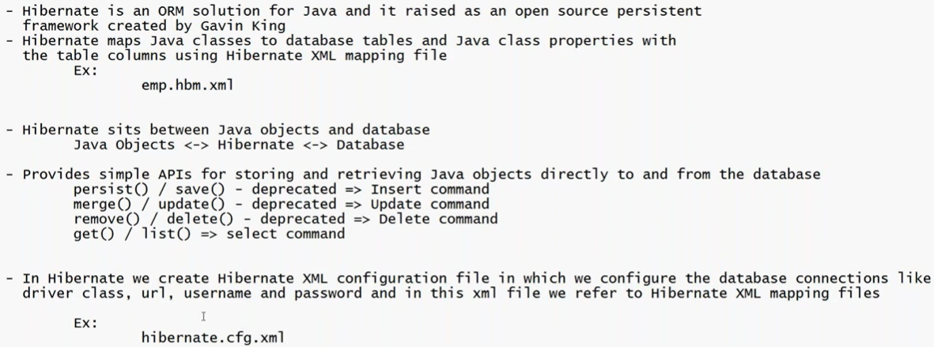

If there is change in database then the only need to change is XML file properties.

69) spring vs hibernate

**Spring = Complete building framework**

**Hibernate = Database handling tool**

70) Developing a Hibernate 6 application in eclipse using Maven

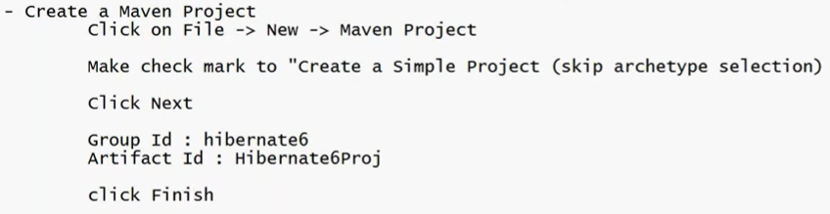

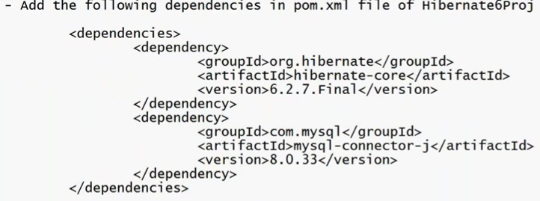

If error come in pom.xml use below:

<project xmlns="http://maven.apache.org/POM/4.0.0"

xmlns:xsi="http://www.w3.org/2001/XMLSchema-instance"

xsi:schemaLocation="http://maven.apache.org/POM/4.0.0

http://maven.apache.org/xsd/maven-4.0.0.xsd">

<modelVersion>4.0.0</modelVersion>

<groupId>hibernate6</groupId>

<artifactId>Hibernate6Proj</artifactId>

<version>0.0.1-SNAPSHOT</version>

</project>

To get your own java version and not the default java version of maven add below code on pom.xml after </dependencies>

<build>

<sourceDirectory>src/main/java</sourceDirectory>

<plugins>

<plugin>

<artifactId>maven-compiler-plugin</artifactId>

<version>3.5.1</version>

<configuration>

<source>21</source> <!--This is java version-->

<target>18</target>

</configuration>

</plugin>

</plugins>

</build>

Save; right click of Hibernate6Proj; go to maven and update project; click ok.



Code of Student.java:

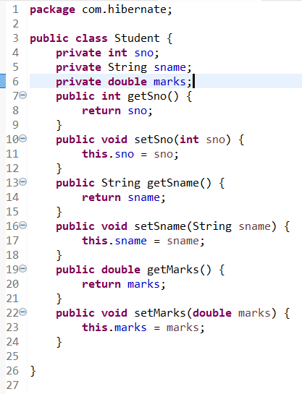



Used to map our POJO class with our db Table.

Code of student.hbm.xml

<?xml version=*"1.0"* encoding=*"UTF-8"*?>

<hibernate-mapping>

<class name=*"com.hibernate.Student"* table=*"StudentInfo"*>

<id name=*"sno"* column=*"sno"*/> <!-- Primary key -->

<property name=*"sname"* column=*"sname"*/>

<property name=*"marks"* column=*"marks"*/>

</class>

</hibernate-mapping>



Code of hibernate.cfg.xml

<?xml version=*"1.0"* encoding=*"UTF-8"*?>

<hibernate-configuration>

<session-factory>

<property name=*"hibernate.connection.driver_class"*>com.mysql.cj.jdbc.Driver</property>

<property name=*"hibernate.connection.url"*>jdbc:mysql://localhost:3306/java_database</property>

<property name=*"hibernate.connection.username"*>root</property>

<property name=*"hibernate.connection.password"*>root</property>

<!-- dialect means SQL command syntax -->

<property name=*"hibernate.dialect"*>org.hibernate.dialect.MySQLDialect</property>

<property name=*"hibernate.connection.autocommit"*>false</property>

<property name=*"hibernate.show_sql"*>true</property>

<!-- to create tables automatically -->

<property name=*"hibernate.hbm2ddl.auto"*>create</property>

<mapping resource=*"student.hbm.xml"*/>

</session-factory>

</hibernate-configuration>



Code of HibernateUtil.java

package com.hibernate;

import org.hibernate.SessionFactory;

import org.hibernate.boot.Metadata;

import org.hibernate.boot.MetadataSources;

import org.hibernate.boot.registry.StandardServiceRegistry;

import org.hibernate.boot.registry.StandardServiceRegistryBuilder;

public class HibernateUtil {

private static StandardServiceRegistry registry;

private static SessionFactory sessionFactory;

public static SessionFactory getSessionFactory() {

if (sessionFactory == null) {

try {

registry = new StandardServiceRegistryBuilder().configure().build();

MetadataSources sources = new MetadataSources(registry);

Metadata metadata = sources.getMetadataBuilder().build();

sessionFactory = metadata.getSessionFactoryBuilder().build();

} catch (Exception e) {

System.out.println(e);

}

}

return sessionFactory;

}

}



Code below:

**package** com.hibernate;

**import** org.hibernate.Session;

**import** org.hibernate.SessionFactory;

**import** org.hibernate.Transaction;

**public** **class** StudentInsert {

**public** **static** **void** main(String[] args) {

SessionFactory sf = HibernateUtil.*getSessionFactory*();

Session s = sf.openSession();

Transaction tx = s.beginTransaction();

Student stud = **new** Student();

stud.setSno(111);

stud.setSname("Raj");

stud.setMarks(500.0);

s.persist(stud);

tx.commit();

s.close();

}

}

Now run the code.

In hibernate.cfg.xml use update if you do not want your old table row to get deleted for addition of new data.

<property name=*"hibernate.hbm2ddl.auto"*>update</property>

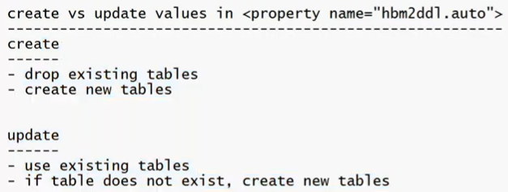

71) why we create package name with com.hibernate or com.learning; why cannot just learning or hibernate

## **To Avoid Name Conflicts (Most Important Reason)**

In large projects, thousands of developers create classes.

Imagine:

* You create → package learning;
* Someone else also creates → package learning;

Now if both libraries are used in one project ❌ **name clash happens**.

But if you use:

package com.aman.learning;

It becomes unique.

## **🔥 So Can You Use Just learning?**

Yes ✅ Java allows it.

But:

* Not recommended
* Can cause conflicts
* Not industry standard

72) Hibernate CRUD operation

Code of StudentUpdate.java

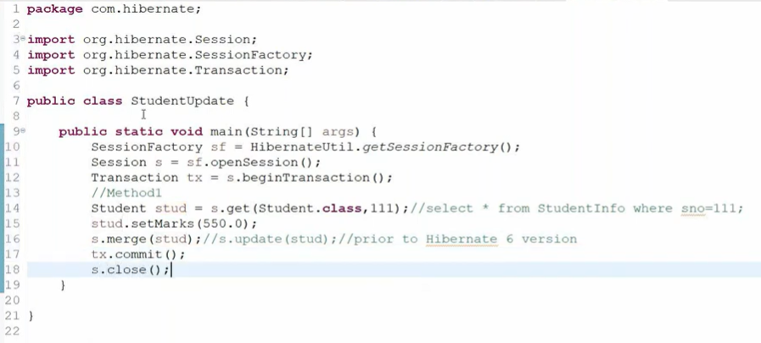

Method 2: using hibernate query language

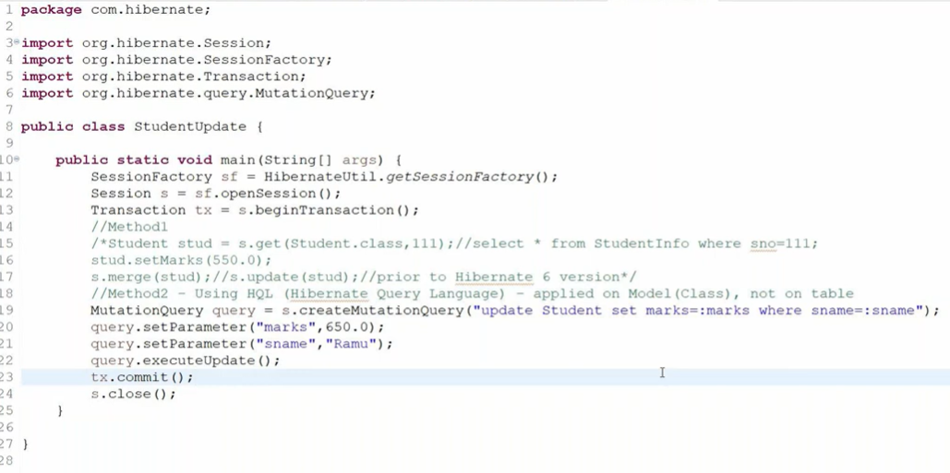

Note that: Student is class name. It is applied on Class and not db table name. That is why HQL.

Code of StudentDelete.java

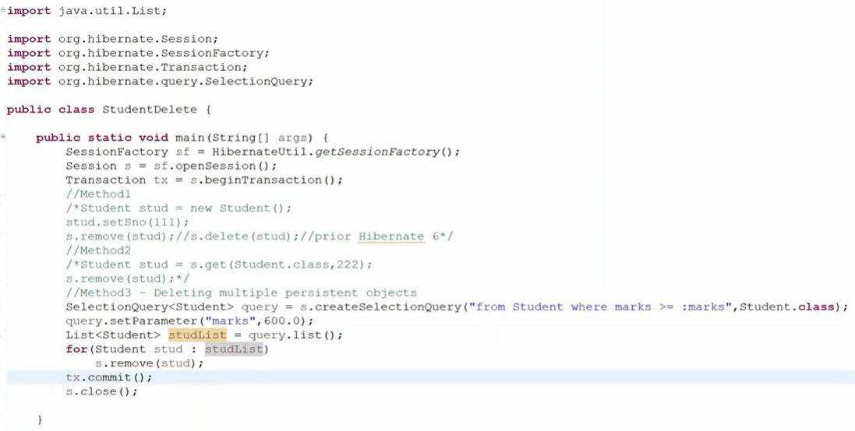

If you want to print the objects override the toString() method in Student.java as:

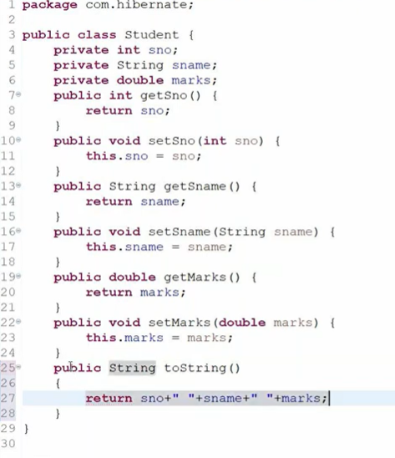

StudentList.java (reading)

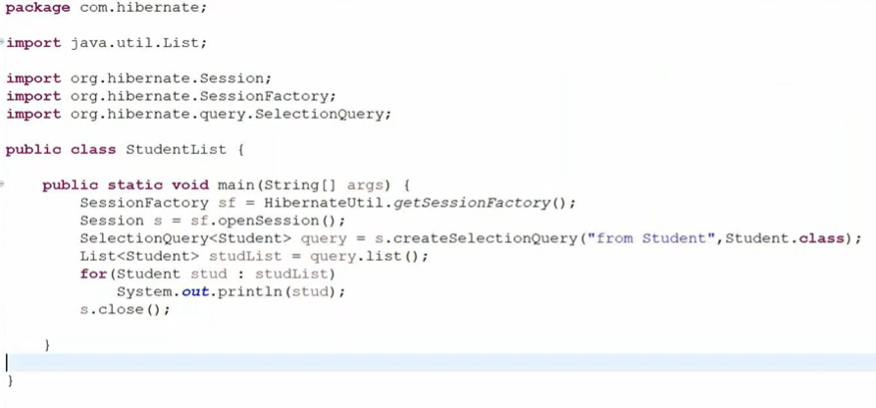

73) Using Annotations in Hibernate

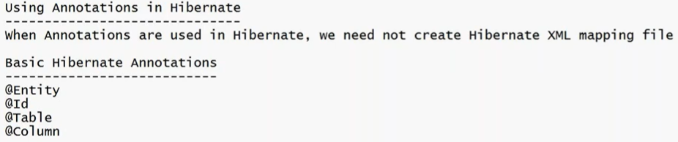

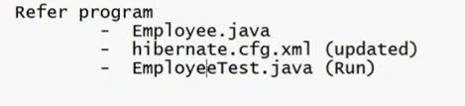

Code of Employee.java

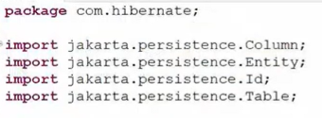

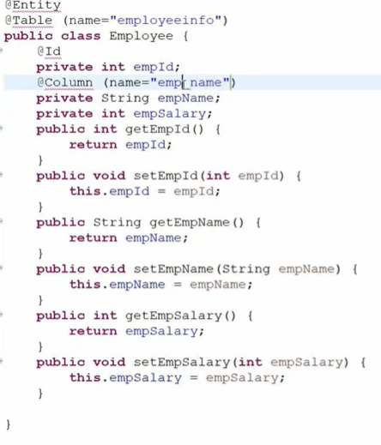

name=”employeeinfo” is the Table name in db . if not given it will keep it as class name. @id is for primary key; column name in db can be changed with @Column annotation.

Just add the below highlighted mapping in hibernate.cfg.xml

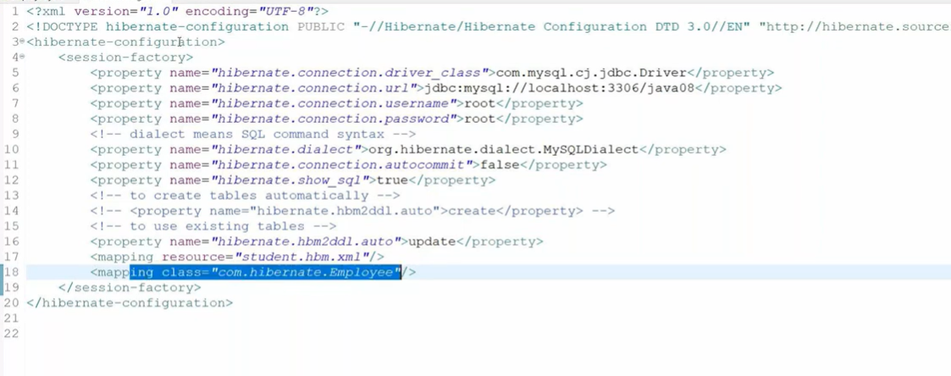

Code of EmployeeTest.java

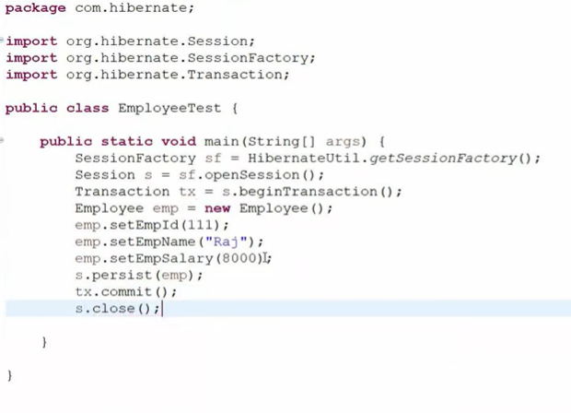

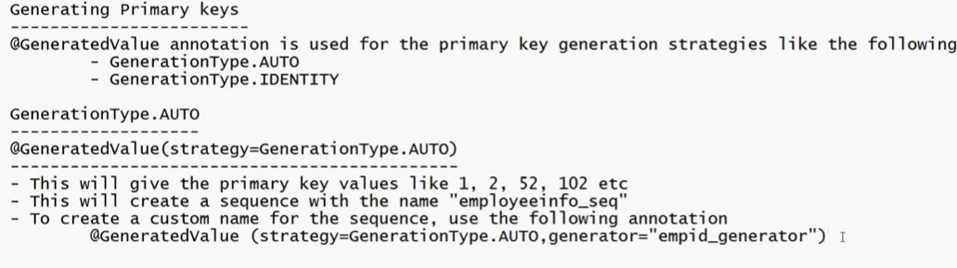

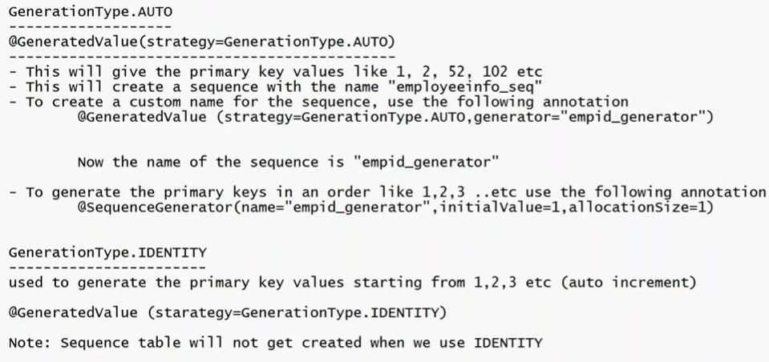

74) order in which annotation in java work. top to down, bottom to up

Annotations in Java are **not executed top-to-bottom or bottom-to-top like normal code**.

They are **metadata**, and their processing depends on**:

* The compiler
* The framework (like Hibernate, Spring, etc.)
* The annotation processor

# **🔹 How Annotations Actually Work**

## **1️⃣ During Compilation**

Some annotations are processed at **compile time** Example: @Override

The compiler checks it immediately.

Order does **NOT** matter here.

## **2️⃣ During Runtime (Reflection / Frameworks)**

For frameworks like:

* Hibernate (@Entity, @Table)
* Spring (@Autowired, @Component)

The framework reads annotations using **reflection**.

👉 It scans the class structure.  
 👉 It does NOT execute them line by line.

So again, **not top-down or bottom-up execution**.

# **🔹 In Your Hibernate Example**

@Entity

@Table(name="employeeinfo")

public class Employee {

What happens?

1. Hibernate scans the class.
2. It sees @Entity → marks class as entity.
3. It sees @Table → maps it to table.
4. It scans fields for @Id, @Column.

It does **not execute** like normal statements.

# **🔹 Important Rule**

If multiple annotations are on same element:

@Entity

@Table(name="employeeinfo")

Their order usually **does not matter** unless:

* One annotation depends on another (rare case)
* Framework specifically defines order

@Entity @Table(name="employeeinfo") what if i write table above entity

### **It will work perfectly fine.**

# **🔹 Why?**

In frameworks like **Hibernate** or **Spring**, annotations are:

* Read using **reflection**
* Collected as metadata
* Processed as a whole

They are **not executed in order like normal Java statements**.

75) coupled means dependent

76) Spring Framework

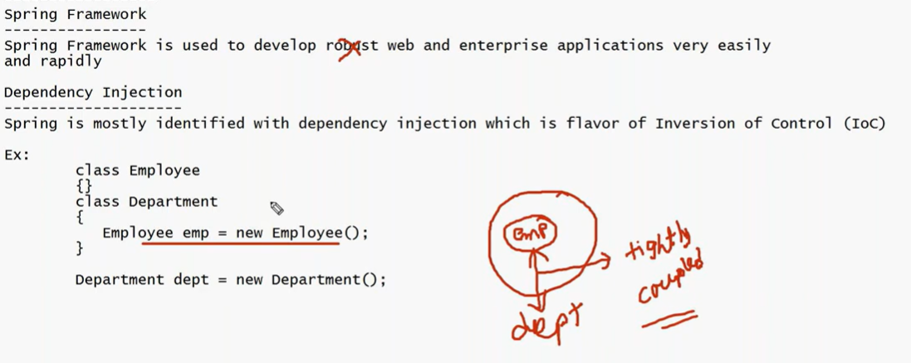

Tightly coupled applications are not robust application.

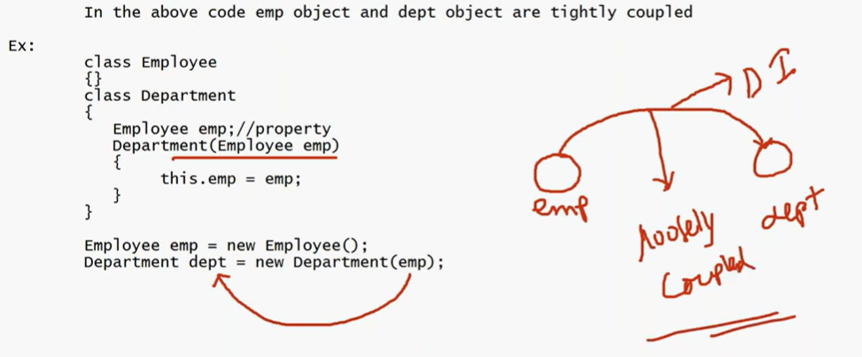

Always we should go with loose coupled applications. DI: giving one object to another.

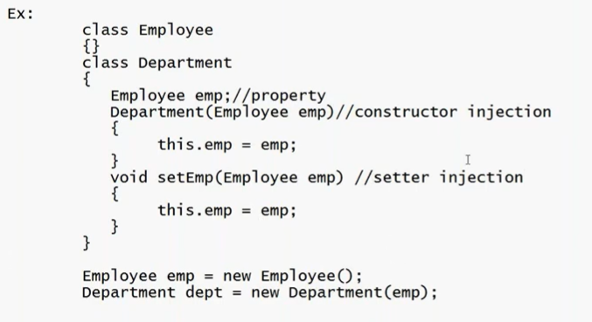

Why Spring Came into picture?

Inside a scope let say we have 100 objects. Grabage collection won’t work until the flow comes out of scope. This can degrade our performance hence it is responsibility of a programmer to set the object = null after work is done. Like we used to close the connection db object once work is done. If we will not do this then memory exception can come.

To ease this role of programmer of manually setting objects to null Spring came into picture.

Inversion of control: now we are not creating object and setting it to null after usage. Spring is doing it for us. That is why the name inversion of control.

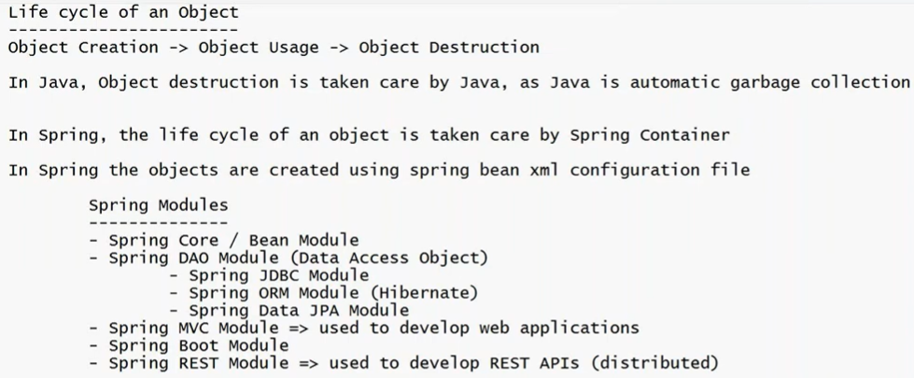

77) developing a Spring application in eclipse using Maven

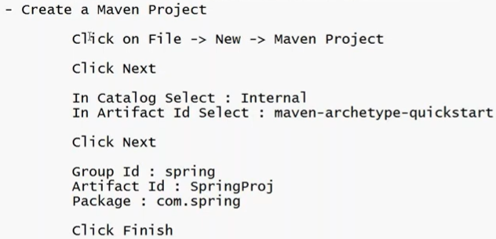

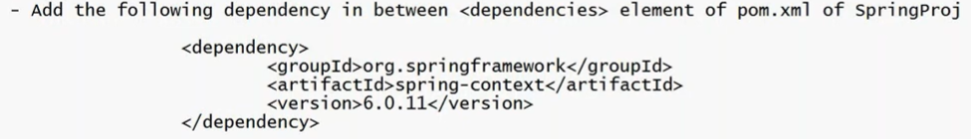



Code of Book.java

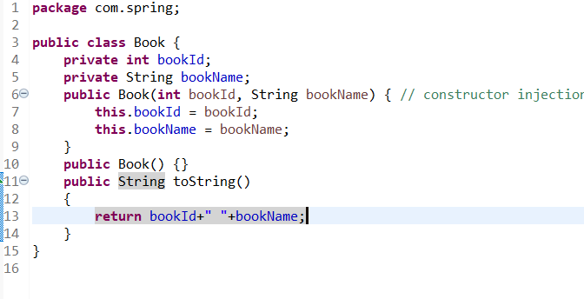

Code of Library.java

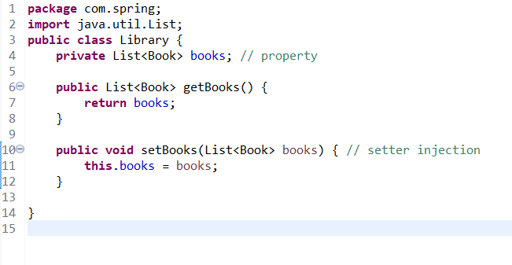



Using above we now do not have to create objects. Spring will do it for us.

Code of library.xml (even though it will show red in eclipse, it will work)

<?xml version=*"1.0"* encoding=*"UTF-8"*?>

<beans xmlns=*"http://www.springframework.org/schema/beans"*

xmlns:xsi=*"http://www.w3.org/2001/XMLSchema-instance"*

xsi:schemaLocation=*"*

*http://www.springframework.org/schema/beans*

*https://www.springframework.org/schema/beans/spring-beans.xsd"*>

<bean id=*"lib"* class=*"com.spring.Library"*>

<property name=*"books"*>

<list>

<ref bean=*"book1"*/>

<ref bean=*"book2"*/>

<ref bean=*"book3"*/>

</list>

</property>

</bean>

<bean id=*"book1"* class=*"com.spring.Book"*>

<constructor-arg value=*"111"*/>

<constructor-arg value=*"Learn Spring"*/>

</bean>

<bean id=*"book2"* class=*"com.spring.Book"*>

<constructor-arg value=*"222"*/>

<constructor-arg value=*"DSA"*/>

</bean>

<bean id=*"book3"* class=*"com.spring.Book"*>

<constructor-arg value=*"333"*/>

<constructor-arg value=*"Learn Django"*/>

</bean>

</beans>



Code of LibraryTest.java

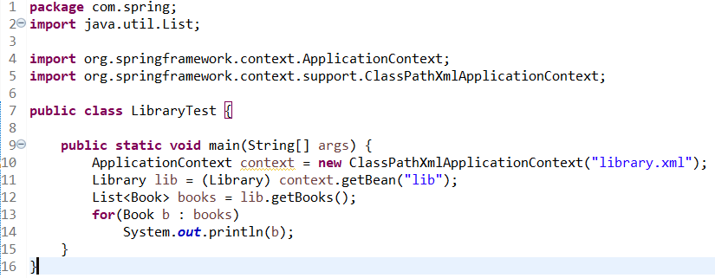

And run this file

78) see below

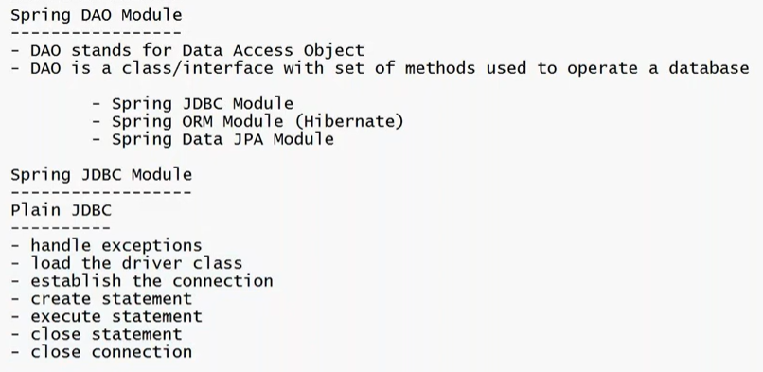

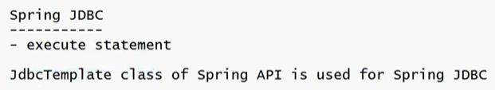

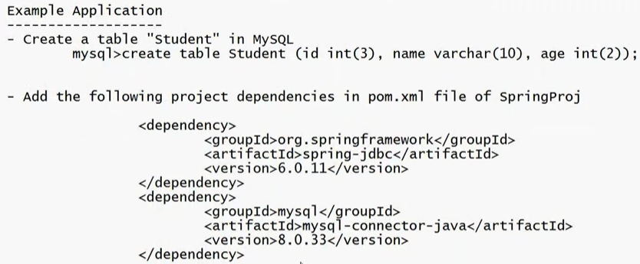



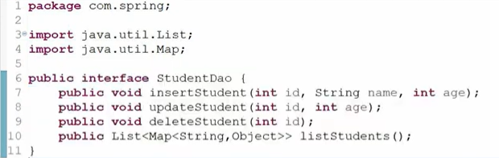



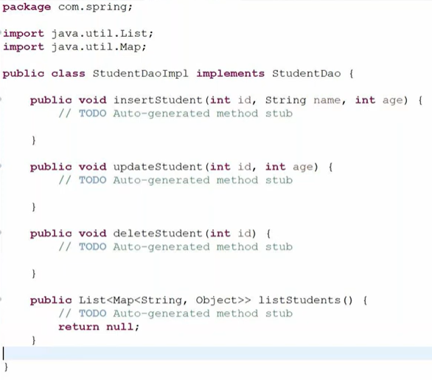

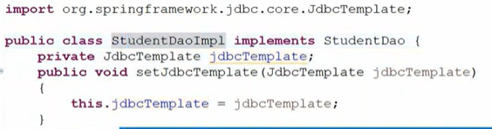

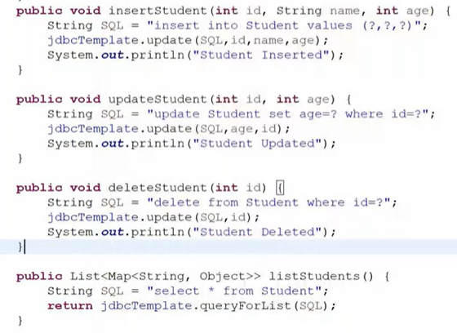



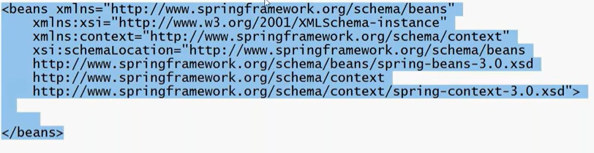

Paste in jdbc.xml;

Update jdbc.xml as below

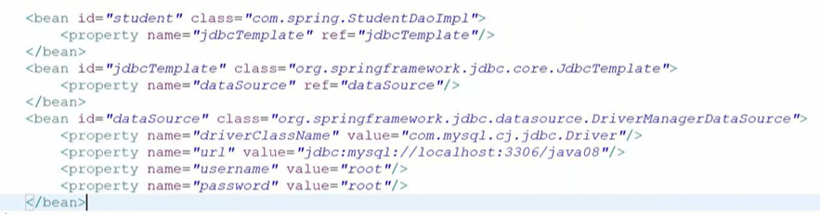



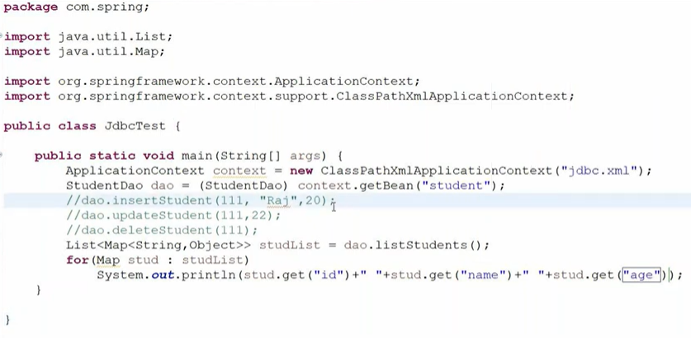

79) Spring ORM module (Hibernate)

Vid 42: <https://www.youtube.com/watch?v=jL9A90KvgDk&list=PLU2wpJsXyAjnmTQPc4KM7kP1dq2lnkQ5O&index=42&pp=iAQB>

80) Spring MVC Module

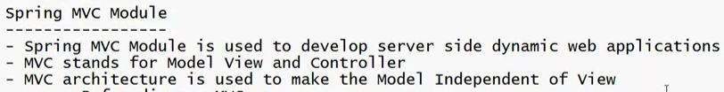

As we can see, in MVC arch we have kept model independent of view

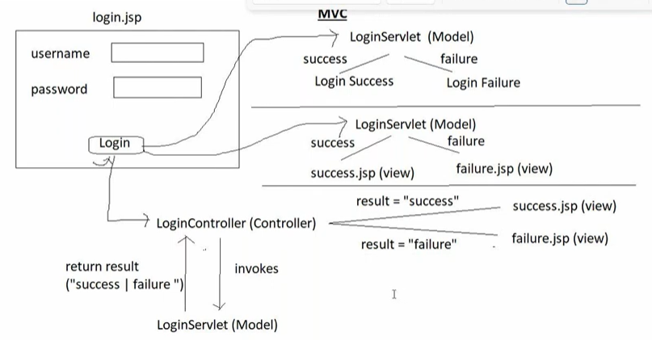

Django’s View = MVC’s Controller

MVC vs MVT vs MCP

# **MVC – Model View Controller**

**Used in:**

* Spring Framework
* ASP.NET
* Laravel

### **🔹 Structure**

User → Controller → Model → Controller → View → User

### **🔹 Components**

### **✅ Model**

* Handles data
* Database logic
* Business rules

### **✅ View**

* UI layer
* Displays data (HTML, JSP, etc.)

### **✅ Controller**

* Receives user request
* Calls model
* Sends response to view

### **🔹 Example (Spring MVC – relevant to you)**

When a user submits a form:

@RequestMapping("/save")

public String saveUser() {

service.save();

return "success.jsp";

}

* Controller handles request
* Service/Model processes data
* View renders response

# **MVT – Model View Template**

**Used in:**

* Django

MVT is basically **Django’s version of MVC**.

### **🔹 Structure**

User → View → Model → View → Template → User

### **🔹 Components**

### **✅ Model**

* Same as MVC
* Database tables (you’ve used this in Django models.py)

### **✅ View (Important difference ⚠️)**

In Django:

* View handles request logic
* Returns template
* So Django’s View = MVC’s Controller

### **✅ Template**

* HTML files
* Frontend rendering
* Django template engine

### **🔹 Why Django changed naming?**

Because:

| **MVC** | **Django Equivalent** |
| --- | --- |
| Model | Model |
| View | Template |
| Controller | View |

Django designers felt:

“Templates define what user sees, so that’s the View.”

# **MCP – Model Context Protocol**

This one is different.

MCP is not a classical web architecture like MVC/MVT.

It is associated with modern AI systems and LLM-based applications.

Recently popularized in AI tooling ecosystems.

It enables:

* LLMs to connect to tools
* Context sharing
* Structured communication between models and systems

It’s used in AI agent frameworks, not traditional web apps.

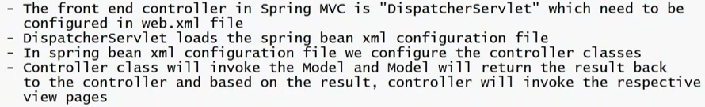

81) In order to learn Spring MVC we need to learn some annotations as:

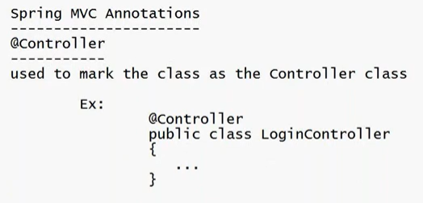

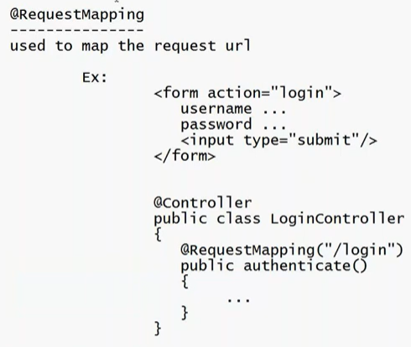

82) Developing a Spring application in Eclipse using Maven

+ create tomcat server in in eclipse workspace. Steps to add tomcat server by going to windows in header of eclipse then runtime environment then server is done very above.

+ create a maven project

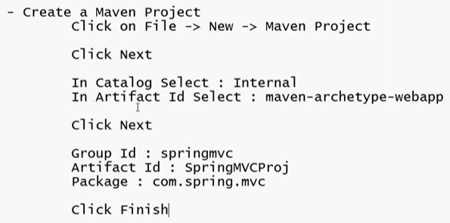

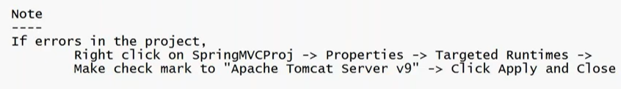

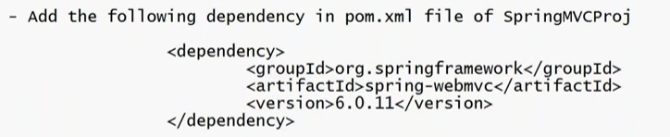



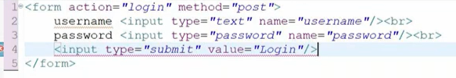

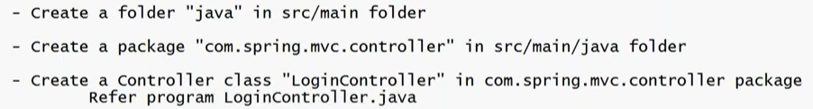

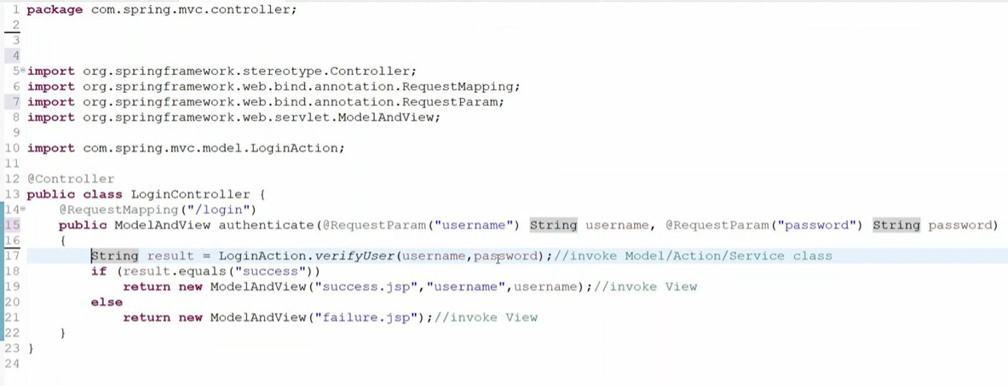



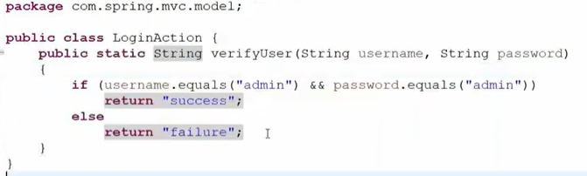

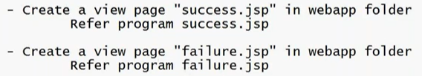

success.jsp



failure.jsp





Web.xml is in WEB-INF folder

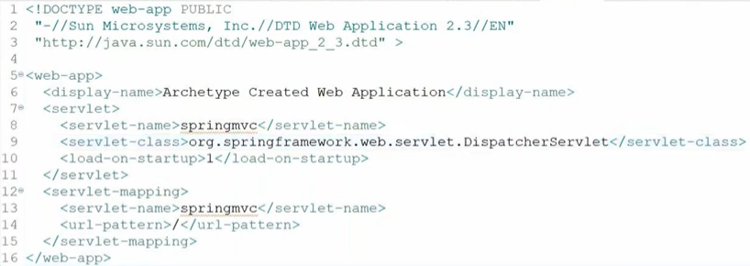





Template code of springmvc-servlet.xml

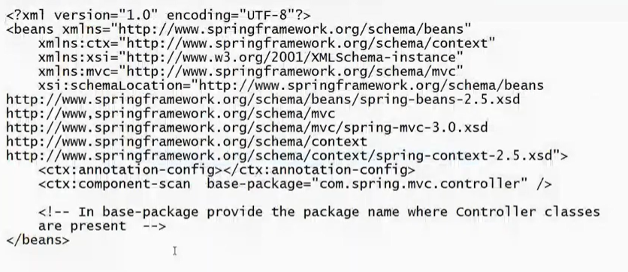

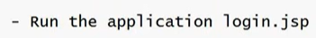

If error then use below version in pom.xml

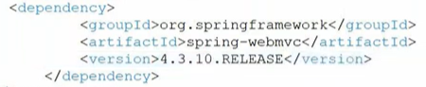

How Spring MVC works:

When you make a request first it goes to web.xml file;

web.xml file will load DispatcherServlet



DispatcherServlet will load SpringBean xml file (springmvc-servlet.xml);

This xml file identifies the package name where the controller class is present



Goes to controller class and how it knows it is controller class using @controller

Based on action name (here /login) this method will get executed below the requestmapping controller.

83) Spring Boot module

Comes with embedded tomcat server so we do not manually have to download and setup.

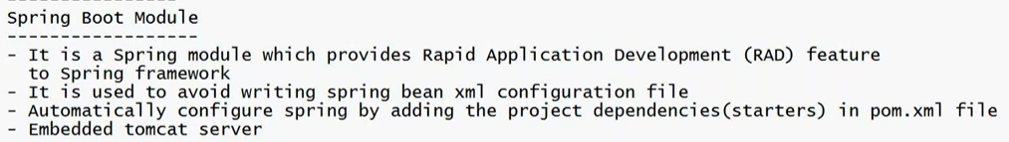

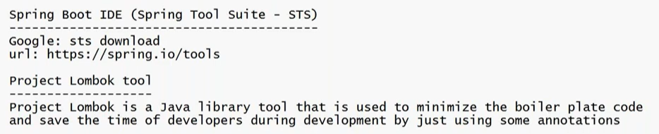

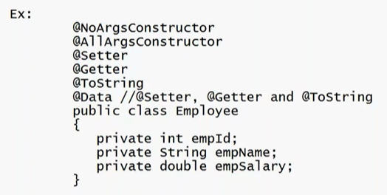

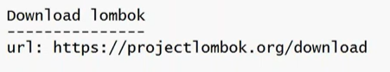

And do some things : discussed at 18:00 L44

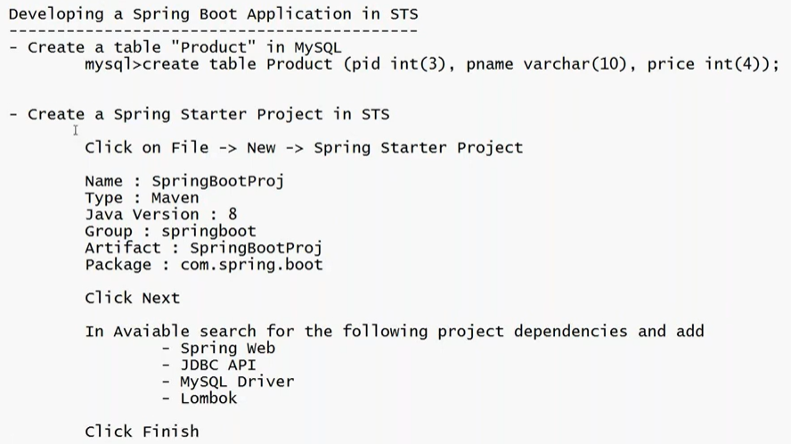

See L44 to know about developing a spring boot application in STS:

<https://www.youtube.com/watch?v=1Iffr7JqSfE&list=PLU2wpJsXyAjnmTQPc4KM7kP1dq2lnkQ5O&index=44&pp=iAQB>

84) videos you may watch if needed; imp things are added for quick ref

L45: Spring Boot Rest API with Spring Data JPA **(vvi lec for spring boot)**

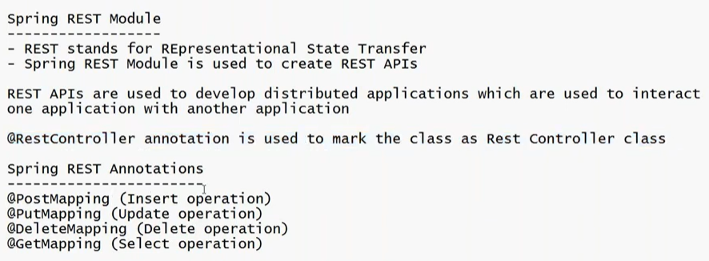

L46: JUnit5 with Mocking

L47, 48: Java Microservices with Spring Boot

Monolithic application: are made using one technology only

Microservices: many components are involved like in amazon for searching one language, for filtering other language etc.





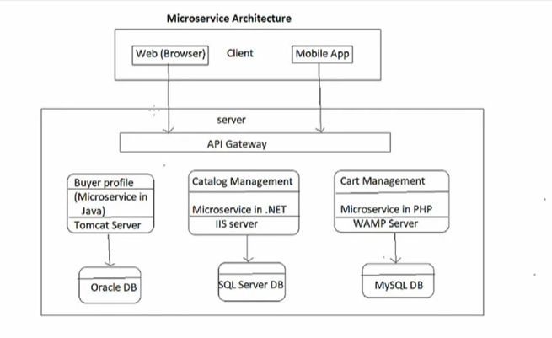



L49, 50, 51: Angular Framework

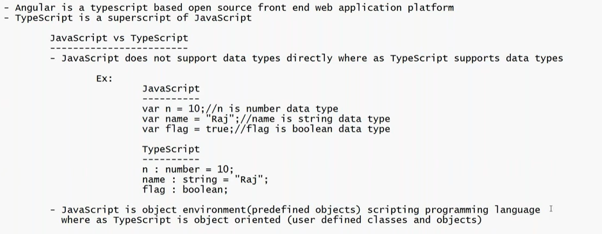

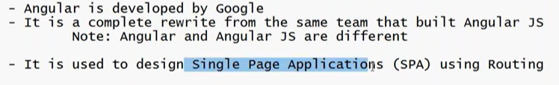

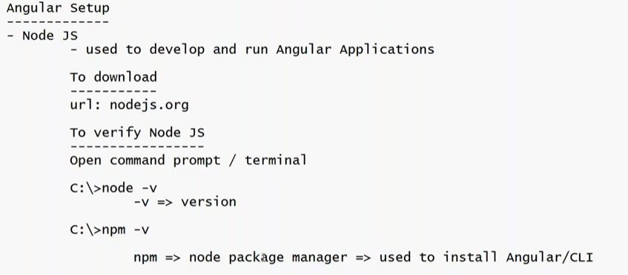

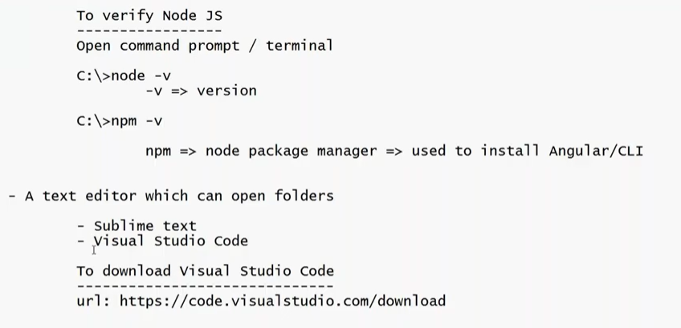

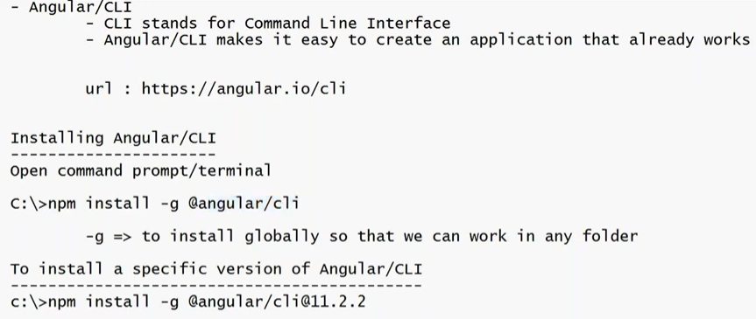

ng version: type in cmd to get angular version

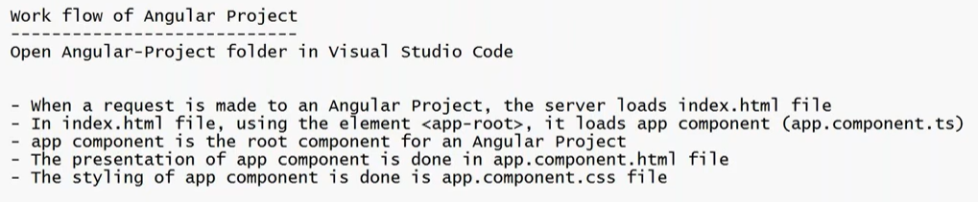

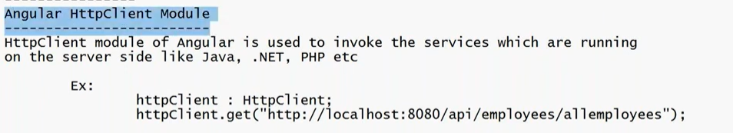

85) from L53, full time java real time projects. Very good theories about diff tech stack and technologies along with implementation.

86)

Misc:

